- THE TRANSFORMER
With an functional amplifier capable of switching >60V within 80ns of a 2V square input pulse let us now consider the transformer which will further amplify the pulse (recall fig 3.2).

5.1 Theoretical Background

The non-ideal Transformer

There various equivalent circuits by which a non-ideal transformer may be modelled. We will consider (fig 5.1) the ‘textbook’ non-ideal transformer (see [11]), to select an appropriate transformer design for maximal voltage gain and minimal rise time.

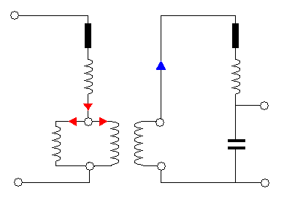
Ideal Transformer
Non Ideal Transformer
V'_{i}
V'_{o}
V_{i}
V_{o}
R₁
L₁
L_{m}
R₂
L₂
N₁
N₂

I₂

I₁

Cw

Fig 5.1 A common non-ideal transformer equivalent circuit. Series resistors R₁ and R₂ account for Ohmic losses in the coils, and inductances L₁ and L₂ represent their ‘leakage’ inductances – where induced flux fails to link both coils. L_{m}, the ‘magnetising inductance’ determines the voltage V'_{i} across the primary of the ideal transformer region as input current I₁ varies. Charging of the secondary windings is accounted for by a ‘winding capacitance, C_{w}, across the output.

Fig 5.1 treats the non-ideal transformer as an ideal transformer with a selection of parasitic inductances and resistances associated with each coil and a ‘magnetising’ inductance L_{m} which determines the amount of back e.m.f. dropped across the primary of the (notional) ideal transformer. Additionally, the multiple adjacent windings of the secondary introduce a finite ‘winding’ capacitance C_{w} across the secondary output. The parasitic (‘leakage’) resistances are associated with the finite resistance of the coil wires, and the leakage inductances reflect flux generation in either coil that fails to link its partner successfully. Simple application of Kirchhoff’s law to both primary and secondary circuits allows us to define the input voltage of the ideal transformer V'_{i} and the output voltage V_{o}.

V'_{i} = V_{i} – I₁R₁ – L₁(dI₁/dt) {4}

V_{o} = V'_{o} - I₂R₂ – L₂(dI₂/dt) {5}

Note that all voltage and current terms vary with time, though subscripts are dropped for convenience. The input and output voltages across the ideal transformer can be related by the familiar expression:

V'_{o} = V'_{i} (N₂/N₁) {6}

Substituting {6} into {5} we find:

V_{o} = V'_{i} (N₂/N₁) - I₂R₂ – L₂(dI₂/dt)

We may in turn apply {4} to this expression and relate V_{o} to V_{i} as follows:

V_{o} = [V_{i} – I₁R₁ – L₁(dI₁/dt) ](N₂/N₁) - I₂R₂ – L₂(dI₂/dt)

V_{o} = V_{i}(N₂/N₁) – [I₁R₁ + L₁(dI₁/dt) ](N₂/N₁) - I₂R₂ – L₂(dI₂/dt) {7}

Notice that the form of {7} at any instant suggests a linear relationship between input and output voltages:

V_{o} = V_{i}(N₂/N₁) + A(t) {8}

where A(t) is a constant that will vary in time according to the relative dominance of each leakage term in {7}. This expression is identical to that of an ideal transformer, {6} when leakage terms are zero – i.e. A(t) = 0 – as expected. In seeking to reach a threshold output voltage to discharge a spark plug (see Section 3) within our 500ns ideal response time we will consider both the magnitude of this ‘leaked’ voltage A(t) and also the resonant behaviour of the non-ideal transformer of fig 5.1.

5.2 Transformer Design and Fabrication

Ultimately it is the dielectric breakdown potential of the air in the spark plug - taken as 3.13±0.2MVm⁻¹ [14] where the uncertainty reflects changes of pressure and temperature during typical lab bench conditions – above which we expect reliable sparking. The 0.8±0.01mm cathode/anode separation of the spark plug therefore demands V_{o}>2.5kV. It is of course desirable to minimise the amount of ‘stepping-up’ demanded of our transformer as this will reduce the total number of transformer windings required and hence also the unwanted leakage of the coils. An eight turn primary was selected according to the recommendation of the NIKHEF team [15] and is a sensible trade-off between lower primary resistance (fewer turns) and ensuring that the majority of V_{i} falls across the inductive component of the coil rather than its resistance (more turns). As recommended we will wind ~350 turns onto the secondary winding, giving an ideal voltage gain of N₂/N₁ = 350/8 ≈ 44 according to expression {6}. The IGBT will be operated <180V to protect adjacent components, giving an ideal output voltage of 7.9kV – comfortably above the 2.5kV threshold.

We choose to hand wind our transformer, selecting the device materials and geometry to most successfully limit flux leakage, and hence leakage inductances. Simple features – addition of a flux shaping ferrite core and use of low resistivity copper wire – are complimented by careful consideration of device geometry, which places the following constraints on our design (fig 5.2):

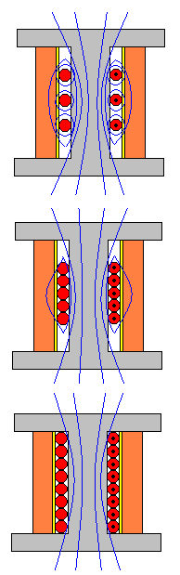
Fig 5.2 Cartoon illustrating how transformer design can be adjusted to limit flux leakage.
Leakage flux between primary windings
Leakage flux around primary windings
Flux successfully linking both coils
Secondary windings
Primary windings
h
Coil-former
(c)
(b)
(a)
- Linear design
The primary coil is completely enclosed by the secondary such that the majority of flux naturally links the secondary windings.

- Adjacent winding
Both coils will be wound carefully by hand to ensure no gaps are left between adjacent windings through which flux can leak.

- Coil bed matching
Primary and secondary solenoids will have approximately equivalent lengths, h, minimising the amount of flux leakage between primary and secondary layers.

In addition to flux leakage considerations our device must be compact and robust. We settle on a bed length of h = 10mm. Choosing primary and secondary wire diameters at 0.85mm and 0.19mm diameter the primary will fall slightly shorter than the full bed length (6.8mm), but the secondary can be wound as 7 layers of 53 secondary windings, totalling 371 turns – a 1:46 ratio ideal for our purposes. Raising 180V at the primary to ~8kV, the far ends of adjacent beds of the secondary coil will therefore experience potential differences of a few kV (see fig 5.3) and so each layer is bound with several layers of insulating ‘Kapton’ tape. The complete schematic of this design is shown below (fig 5.3).

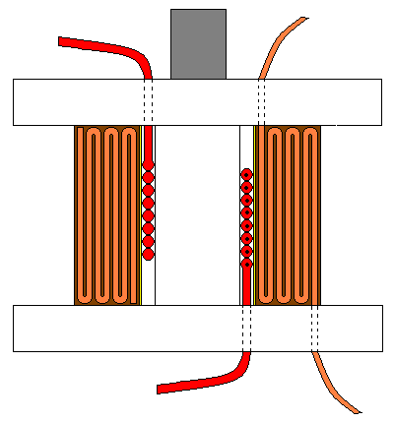
0V
0V
180V
~8kV
Secondary windings;
7 layers; 53 windings per layer
Primary windings;
8 windings indicated individually
Retractable ferrite core
Each layer accommodates ~1.1kV. Thus adjacent layer endings are at potential differences of ~2.2kV
Highly insulating ‘Kapton’ tape prevents internal sparking between secondary layers
h = 10±0.1mm
w ≈ 8mm
t ≈ 4mm
Coil former machined from insulating (plastic) material
Layer of stiff card to support secondary windings

Fig 5.3 Schematic detailing the design of our fast switching transformer. Note that the primary windings are laid adjacent to one another, and the coil placed centrally – both designed to minimise the leakage inductance as much as possible, according to the qualitative reasoning illustrated in fig 5.2.

5.3 Construction and Experimental Setup

Working from fig 5.3 the transformer was assembled and mounted as shown in fig 5.4. Following a failed first attempt, great care was taken to completely isolate adjacent layer ends using 3-4 layers of insulating tape. A spark gap was added to the output of the secondary to ensure that accidental triggering of an unloaded transformer will discharge safely rather than by internal sparking. The sense of the windings is chosen such that the negative pulse expected on the primary will produce a positive pulse on the secondary – the spark plug will be held within a positive potential in the spark gap and so we require excess positive voltage to exceed the breakdown threshold. Short, thick external leads were selected to minimise unwanted external inductance and resistance of the connecting circuit which may add to the device rise time, and high voltage resistant cable was used as appropriate.

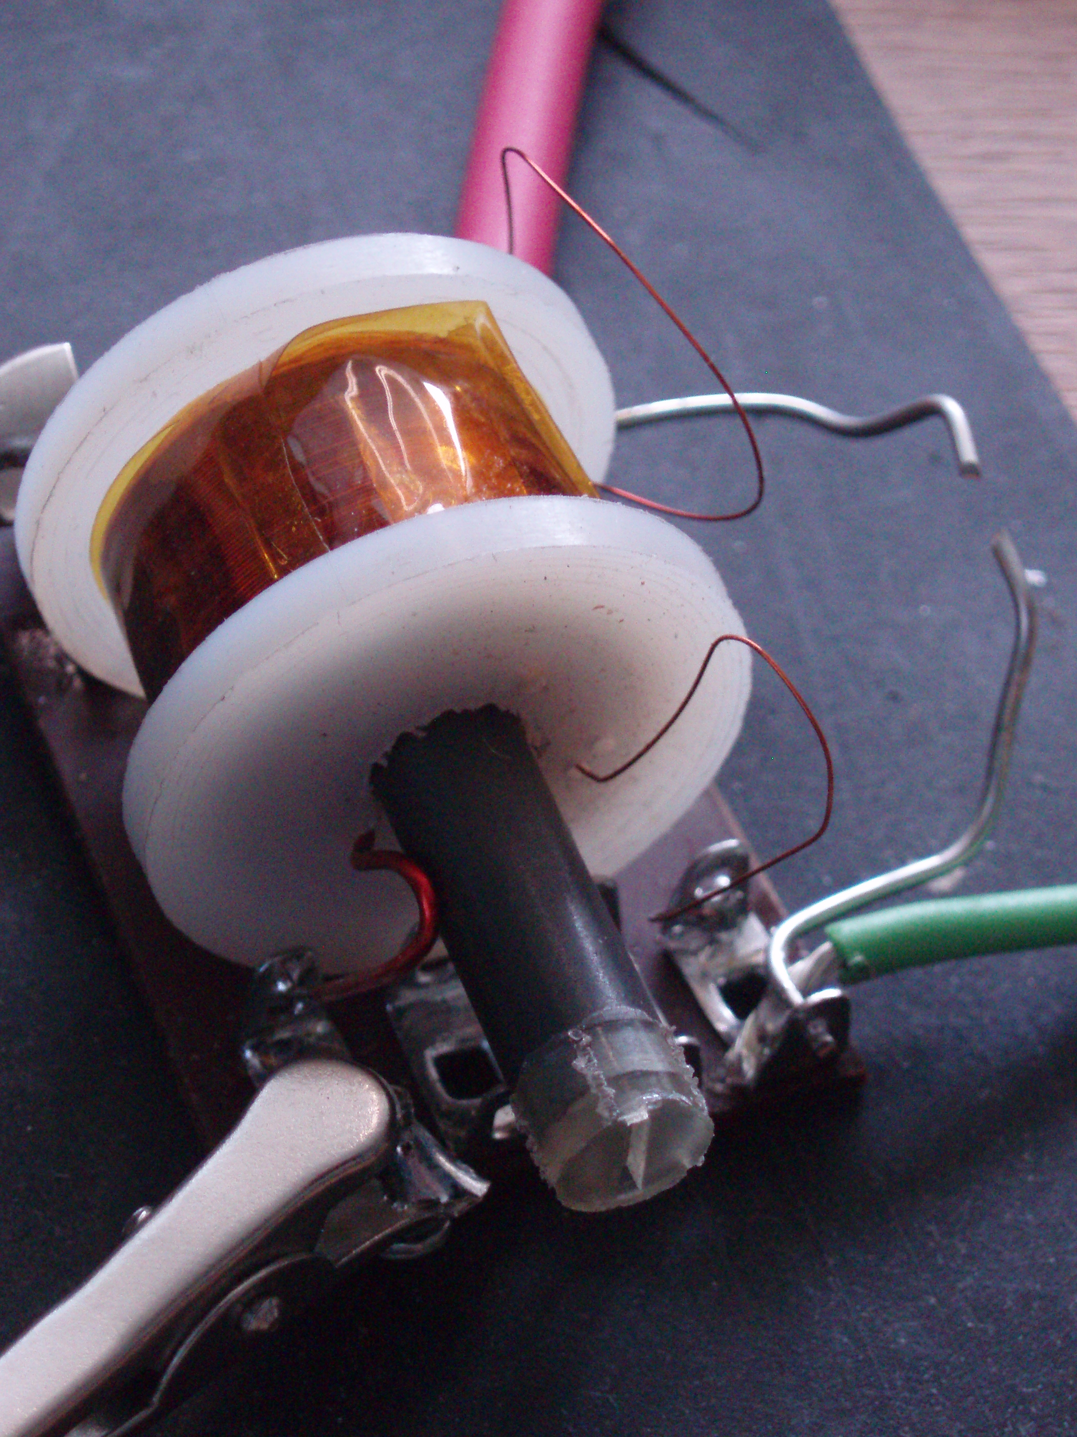
Secondary Output; ~ +2.2kV pulse
Primary Input;
-180V pulse
Insulating tape

Failsafe Spark Gap
Secondary Windings

Plastic coil-former
Secondary Ground

Primary Windings

Retractable Ferrite core

Primary Ground

Fig 5.4 The completed transformer, indicating the position of components shown schematically in fig 5.3

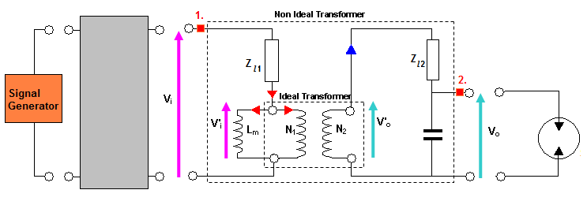
A series of experiments was undertaken to assess the behaviour of the device. Our interests are primarily the device gain – whether we can successfully exceed the breakdown voltage required to trigger the spark plug – and its rise time – whether this breakdown will occur fast enough to ensure our overall delay time is held beneath our target 500ns. Using the experimental arrangement shown in fig 5.5 probes were placed across primary and secondary transformer windings, measuring V_{i} and V_{o} respectively, and our pulsing circuit constructed in Section 4 drives the circuit for a few hundred nanoseconds and at varying input voltages. Attaching the transformer output to the spark plug we will examine the system response below and above the discharge threshold. Note that probing the output’s high voltage spikes is no easy task and we are limited to below the 5kV maximum voltage rating of our most robust probe.
IGBT
Circuit
Spark Plug 0.84±0.01mm

Fig 5.5 Experimental arrangement used to assess transformer behaviour. The system is probed at transformer input (1) and output (2) to observe the relationship between V_{i} and V_{o}. The leakage resistances and inductances are lumped together for the purposes of this investigation.

During preliminary testing we find that the V₀ only attains its maximum value if the IGBT is open for 800ns. This is achieved by ensuring the input pulse duration is increased to >200ns – 600ns will be used for the following experiments.
5.4 Results and Discussion

Pulse Distortion, Finite Rise time and LC oscillation

The first crucial insight into the behaviour of our transformer is in the elegant profile of the output voltage. Typical behaviour is shown in fig 5.6 below for below threshold output voltages (fig 5.6a) and including sparking (fig 5.6b):

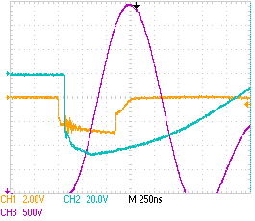
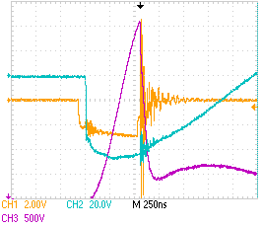
(a)
(b)
~800ns
~700ns
3.9kV
3.7kV

600ns
64V

Fig 5.6 Probing the voltage at the transformer primary (blue trace) and secondary (purple trace) coils. Though the system is driven at identical primary voltages we observe either (a) voltage oscillation but no breakdown or (b) breakdown before peak voltage. Note that this breakdown occurs around 4±1kV, where this large spread reflects the complex and chaotic physics of discharge occurring in the spark plug.

The most striking thing about fig 5.6 is the relatively long, >700ns rise time of the secondary voltage. By comparison, the IGBT switching time of <20ns (exactly as suggested by [13]) applies the primary voltage almost instantaneously. Already we observe significant deviation from ideal transformer behaviour - where we would expect such a step change to drive a step change in secondary voltage. In fact we observe zero secondary voltage when the primary is activated – highlighted by the red vertical line in fig 5.6a. We then see up to 800ns of finite, sinusoidal rise time during which comparatively little voltage variation is observed across the primary. It is imperative for us to rationalise this behaviour, since sparking is observed only when the output attains a threshold voltage – see fig 5.6b – at which point the spark plug is discharged. It is interesting to observe that this threshold is highly variable, occurring at 4±1kV – we see sparking in 5.6b at 3.7kV but no sparking in 5.6a despite higher output voltages. This variation is too large to be simply attributed to 5% daily changes in atmospheric pressure, and must reflect more complex discharge physics within the spark plates.

Fortunately during the first 700ns after the input pulse - of most interest in our quest to minimise secondary voltage rise time - the primary voltage changes little (fig 5.6a). In this approximation a ~-60V step function is applied to the primary and passes onto the secondary coil undistorted. Careful inspection of our non-ideal transformer equivalent circuit (fig 5.1) indicates that the inductances associated with the secondary windings, L_{s}, experience this step voltage increase in a situation analogous to closing the switch in fig 5.7.

At the instant voltage V'_{o} appears across the secondary windings V_{o} is zero – though there is voltage across the primary none is observed because we are probing across an empty winding capacitance. As the situation to evolves (i.e. we close the switch), current begins to flow onto the winding capacitance C_{w} which gradually acquires charge Q(t) and hence voltage V(t) = Q(t)/C_{w.} Applying Kirchhoff once again we see:

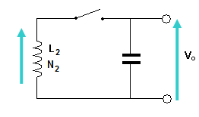
L_{s}(dI/dt) - Q(t)/C_{w} = 0
V'_{o}
C_{w}
Fig 5.7 Simplest equivalent circuit for the transformer output.

L_{s}

Since the current I = dQ/dt this expression may be written,

L_{s} (d²Q/dt²) - Q(t)/C_{w} = 0

which has a simple sinusoidal solution Q(t) α sin(ωt) α V(t), with a characteristic frequency ω = (L₂C_{w})^{-1/2} and thus time period, T = 2π/ω, of

T = 2π(L_{s}C_{w})^{1/2} {4}

This highly simplified analysis goes far to rationalising the sinusoidal output voltage rise time observed in fig 5.6. The LC model’s prediction of zero amplitude secondary voltage at the instant of voltage appearing across the primary, followed by sinusoidal oscillation is consistent with the behaviour observed during the rise time of our system. Furthermore, the model provides several powerful predictions which will aid us in reducing the 800ns rise time to below 500ns. Firstly, we observe that expression {4} suggests that the period of our oscillation should be independent of pulse amplitude. We therefore expect a pulse of double the amplitude of that shown in fig 5.6b to reach sparking threshold voltages in half the time – reducing the rise time to 350ns which is within the our 500ns budget.

Optimising the Rise time

After encouraging preliminary work indicating that the 700ns rise time observed in fig 5.6a is indeed independent of peak output voltage in the range <5kV (limited by the voltage rating of our probe) it was decided to double the input voltage from the -68V to -136V and observe the spark formation time. At these primary voltages the secondary could leap to well in excess of the 5kV which we can safely probe, and so we will observe sparking using a magnetically coupled probe. Due to the variability of the sparking threshold voltage discussed above, we will observe the system for 1000 pulses at 1Hz (i.e. ~17mins continuous operation), collecting a statistical distribution of sparking delay times. The variability in spark times is observed to be of order 100ns and so we will bin the delay times in 10ns intervals. An example of the oscilloscope traces across primary and secondary circuits is shown below (fig 5.8) along with the histogram illustrating the observed distribution of spark delay times across 1000 sparks.

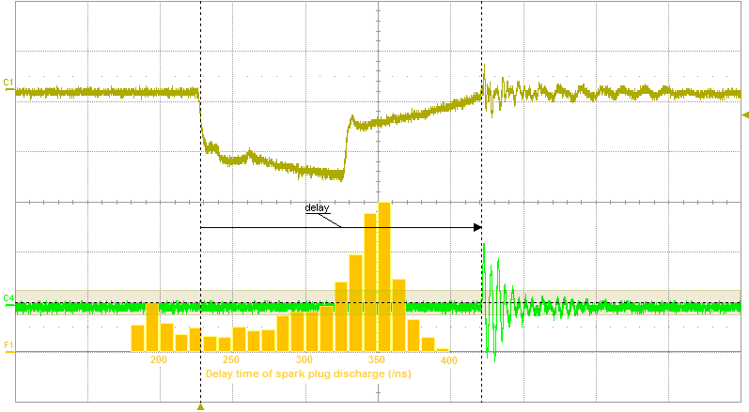
Fig 5.8 Histogram indicating the spread of spark formation times. An overall delay time is measured as indicated, between the leading edge of the square wave input and the discharge, as detected by voltage spiking at the inductive probe. This spike reflects the sudden discharge of the spark plug, and the rapidly changing magnetic fields induced by this current surge. Note that the distribution of delays has a maximum at the expected 350ns, but shows a significant tail early sparking due to the spark plug’s natural variability in threshold voltage.
386ns
200ns
1.8V
Input Pulse from signal generator
Inductive Probe

Both the position and form of the histogram (fig 5.8) are encouragingly consistent with the model of transformer/spark plug operation we have considered thus far. As predicted by our LC resonance model the majority of sparks now exhibit a 350±50ns delay between input pulsing and discharge of the spark plug, where these limits include the most delayed sparks observed. This is pleasingly faster than our 500ns target. This and similar experiments demonstrate conclusively that the overall delay time is indeed halved by doubling the voltage across the transformer primary. The variability of the observed delay times is also of interest. The bias in the distribution towards earlier sparking and the absence of heavily delayed sparks is consistent with a model in which there is an inherent variability in the onset of sparking and above a threshold voltage there is always a breakdown. We can therefore conclude that pulsed at >136V at the primary, our transformer will spark with 100% efficiency within <400ns. Finally, it is observed in further work that raising the primary voltage still further reduces the spread of delay times – a feature which may also be understood within the LC model. The constant oscillation time of the LC circuit raises a higher amplitude secondary pulse more steeply, decreasing the time in which the 4±1kV range of breakdown voltages is traversed and hence squeezing the distribution of delay times to <150ns.

Voltage Gain
A final experiment was undertaken without changing the setup, to investigate the linearity between input and output transformer voltages predicted by expression {8}. For output voltages below the 4kV discharge threshold a range of primary voltages were applied at the IGBT supply rail and recorded using a high impedance digital multimeter accurate to ±0.1V. As before care was taken to use >200ns input pulses from the signal generator so that the system is ‘on’ for long enough to allow the output voltage to attain its maximal value. The secondary voltage is probed as before, and the peak voltage read from a scope to accuracy of within ±10V. We observe the following relationship between input and output voltage (fig 5.9):
This striking tight linear relationship is consistent with all eight tested voltages to within experimental uncertainties (which are of the same scale as the data points). Let us recall expression {8} with which the non-ideal transformer output is theoretically related to its input voltage:

V_{o} = V_{i}(N₂/N₁) + A(t) {8}

In probing V_{i} and V_{o} at a constant delay time – at their maximal values – we fix the constant term A(t) and so we observe a linear relationship between the two as suggested by {8}. Furthermore, we expect the gradient of this plot to reflect the turns ratio with which our transformer was constructed. Somewhat surprisingly, the N₂ = 373 secondary and N₁ = 8 turns recorded during the winding process returns a lower value of (N₂/N₁) = 46.6. Since the coil winding machine is assumed to count the number of secondary turns to within ±1turn and the non-ideal transformer model suggests that only the turns ratio can affect the gradient of fig 5.9 this discrepancy is traced to the primary windings. In threading the stiff primary wire out of the coil former it is certainly possible that one of the end turns has become significantly uncoiled. Losing a single primary turn in this way introduces a ±7 uncertainty into the turns ratio which becomes (N₂/N₁) = 46.6±7 - now consistent with the much more tightly constrained value of 53 determined experimentally by the gradient of fig 5.9.

The non-ideality of our transformer is imaged in fig 5.9 by its -150V offset. For an ideal transformer the non-ideality factor A(t) is zero, and an input vs output voltage plot would pass through the origin, as we would intuitively expect. This -150V can be treated using expression {7} but this more detailed analysis exceeds the scope of this report. Let us content ourselves with the ‘rule of thumb’ observation that our transformer will deliver peak output voltages of 150V short of that predicted for an ideal transformer of the same turns ratio. Considering the operational 4kV maximum output voltage during sparking, this 4% effect is pleasingly small.

