- THE SPARK GAP

Thus far our pulsing circuit now discharges a spark plug within a characteristic time of <350ns. This spark will be used to discharge a prefabricated spark gap (recall fig 3.2) which will eventually raise the ~8kV across plates in a spark chamber. It is suggested in the literature that the break down time of such a triggered spark gap is ~20ns [4] and we therefore aim to discharge our spark gap within <400ns. The following sequence of experiments will assess whether we can achieve such delay times. Crucially, we will investigate the range of voltages that the spark gap can defend in steady state, as this limits the maximum potential difference that can ultimately be delivered to our spark chamber plates. Though the theory of spark formation in a gaseous medium is fascinating and of clear importance to the wider goal of constructing a successful spark chamber, it is complex and falls beyond the scope of this report. The following experiments will therefore be analysed only qualitatively, but their empirical results have profound implications for the operation of our triggering system.

  - Experimental Setup

Introduced in Section 3, the spark gap performs the same high voltage switching function as the IGBT, with the benefit of increased speed and higher breakdown voltages. Our ‘home-made’ device is shown below (fig 6.1) along with the relevant circuit diagram for this sequence of experiments. It is constructed such that the anode/cathode separation distance d can be adjusted over a ~4mm range, to allow a range of different voltages to be defended by a variable air gap.

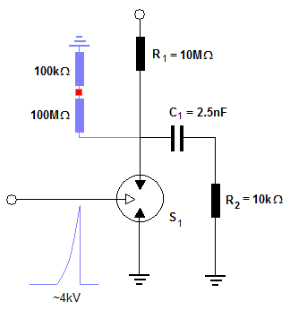
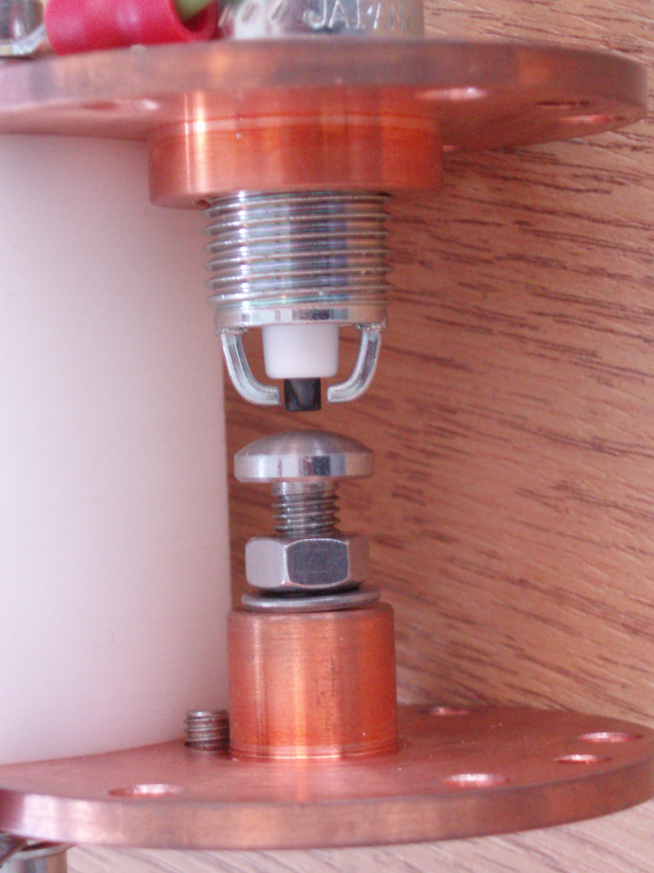
d
~12cm
~10cm
Adjustable Anode Pin
Triggering Electrode
Input from Transformer
~ +6kV

Grounded Plate

Probe point

Output to
Spark Chamber

Fig 6.1 An annotated image of our rudimentary spark gap and the circuit constructed to assess its performance. Note that the anode/ground plate distance d can be adjusted by up to 4mm in the current design, though a full 1cm range is possible with a different anode pin. A 1:1000 potential divider, highlighted in blue, is used to probe the circuit at safe voltages.

Component values are selected to limit the source/ground current when the sparking acts as a short circuit – R₁ = 10MΩ at 6kV will pass 0.6mA, comfortably below the 2mA rating of the voltage supply – and using the RC time introduced in Section 4.4 to select a >1μs high voltage pulse to the chamber plates, ensuring a breakdown occurs – 100pF typical capacitance of small spark chamber plates [4] fixes R₂ =10kΩ. All components were specifically chosen to withstand up to 10kV. Probing as shown, we pulse the circuit with our current triggering circuit, delivering a 4±1kV spike with overall rise time of <400ns – and will vary the anode/cathode spacing and applied voltage to observe and optimise the spark gap discharge time.

  - Methods and Discussion

Steady State threshold Voltage

The basic principle of a spark plug suggests that its fastest operation occur when it holds off a steady state voltage at just beneath its breakdown threshold – in this case the dielectric strength of air 3.13MV/m. It is of primary importance that the device switch as large a voltage as possible, to ensure the output pulse to the chamber plates is large enough to induce reliable sparking. We therefore run a simple preliminary experiment to determine the steady state voltages defended by the un-triggered spark gap as the gap width is varied. We increase the supply voltage and note the potential at which continuous breakdown occurs - as recorded with a multi-meter at our probe point – and measure the corresponding gap width using callipers. Uncertainties are limited by the finite variations of ±0.1V at the probe point reflecting the ±100V fluctuations in threshold voltage, and the ‘by eye’ use of callipers to estimate the spark gap. We find that at very small gap widths, d<1mm, the defended voltage increases with gap width as expected, but that at greater widths the breakdown voltage plateaus to a constant 6.7±0.3kV (see fig 6.2). As in previous experiments, this value is constrained only empirically, as the day-to-day different influences (e.g. pressure variations; oxidation of the cathode plate) introduce random variation of ~±300V to these results.
Breakdown Potential of Air indicating uncertainty due to daily pressure variation

The increasing breakdown potential of air between two smooth parallel plates – 3.13±0.3V/m – is included alongside the observed variation of breakdown potential of air with electrode separation. Although our threshold voltages exceed this theoretical limit by up to 1kV this is attributed to the curved geometry of our electrodes (see fig 6.1) and surface effects. Similarly the observed breakdown threshold falls beneath the parallel plate value as the gap width is increased – as the electrodes become less like plates and more like discrete points. Without further analysis at this stage let us exploit the form of this breakdown curve and select a gap width of 2mm for further delay time experiments, as it is at this point represents the ideal compromise between high threshold voltage – we require as large voltages as possible to be switched to the spark chamber – and narrow electrode separation – which we expect to favour faster switching times.

Delay time

Using an identical experimental arrangement (fig 6.1) but now imaging at the probe point with an oscilloscope and selecting a constant 2mm gap width, the supply voltage was decreased from the threshold voltage for continuous breakdown - 6.7±0.3V – until no spark developed. Delay times were recorded at the scope as illustrated below (fig 6.3):
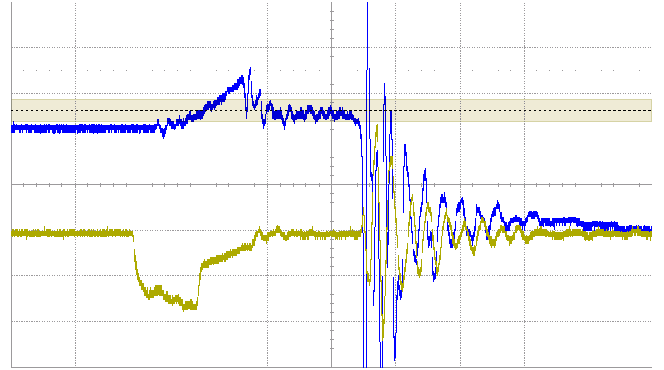
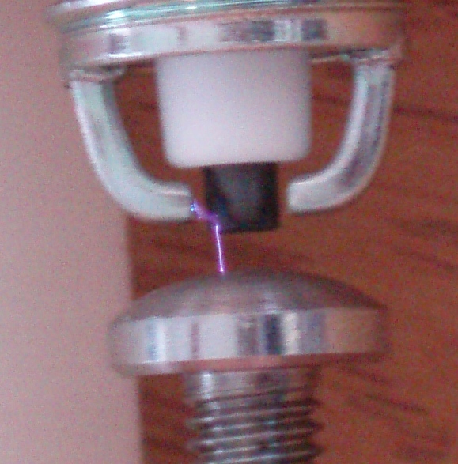
Fig 6.3 Recording the spark formation time by probing the spark gap electronics. The 200ns, 1.8V input pulse is shown in gold, and the 1000x attenuated supply voltage to the spark gap in blue. The 4V collapse after 680ns therefore reflects the shorting of the ~4kV voltage as the spark gap discharges. The initial rise and 320ns decay at the spark plug reflects magnetic coupling of the system to the transformer flux, and its discharge when the spark plug discharges. The physical appearance of the discharge is inset – note that the spark jumps the gap at its narrowest point.
320ns
640ns
~4V
Spark plug discharge

Spark gap discharge

Let us briefly consider the form of behaviour observed across the spark plug in fig 6.3, noting that it is this signal that will also be output to the spark chamber. In this example only a modest 4kV is dropped across the output, but the overall rise time, although not yet within our 500ns target, is nonetheless a pleasing 640ns. At such rise times we might expect to see 85% efficient sparking [1] if we can ultimately apply 8kV to our chamber. Also encouraging is the observed spark plug decay within 350ns as expected for our optimised pulsing circuit (see fig 5.8).
Let us look now at how this decay time reacts as we vary the supply voltage to the spark gap (fig 6.4). As before, the natural variation in delay times at any given voltage is accounted for by observing 1000 sparks and taking the delay time around which the distribution peaks. The <±500ns half-width of the majority of these distributions (e.g. fig. 5.8) is a negligible source of uncertainty compared to the ±0.1kV fluctuations observed at our potential divider and probe.

The elegant trend of fig 6.4 linking increasing spark gap voltage with shorter formation times hints at some of the detail of the spark formation process that I am sadly unable to enter into here¹. However, several immediate features provide useful direction for further refinement of our completed pulsing circuit. Firstly, there is a smooth transition in the overall spark formation times across several orders of magnitude that is perhaps surprising given the relatively minor changes in supply voltages – between the threshold for spark formation at ~4.4kV and continuous breakdown at ~6.7kV indicated by red lines in fig 6.4. This range of spark formation times from 500ns to 50μs perhaps reflects the exponential multiplicative process by which high electric fields generate the free ion cascades which seed the conductive pathway along which discharge occurs (see [18]).

The practical implications of the strong dependence of formation times on supply voltage are twofold. Firstly our assumption that the fastest switching times will occur when the system is held almost at its breakdown voltage (here 6.7kV) is emphatically vindicated. Secondly, the fastest overall delay time achieved in this experiment is 580±100ns where the 100ns is the approximate half width of the observed distribution of sparking times. Ultimately therefore, we find our complete system to be within striking distance of the 500ns overall rise time which is suggested to produce 100% efficient sparking in a small spark chamber [1] [2].

1. See [17] for a general introduction and [18] for a more practical summary for drift chambers.

