- THE IGBT AMPLIFIER

As we set out to construct the first phase of our pulsing circuit, let us consider briefly the anatomy of electronics successfully operated in the NIKHEF design - introducing the components by which initial amplification will be achieved. A good understanding will be crucial as we tune the circuit to our specific requirements.

4.1 Theoretical Background

Switching Operation of a BJT

The fundamental property of a Bipolar Junction Transistor (BJT) is that of a current amplifier. BJTs come in two flavours depending on their internal doping, but only the pnp type relevant in this investigation will be discussed here (see [9] for a detailed introduction to the BJT). Its electrical symbol is shown in fig 4.1. The device is designed such that current flow from emitter to collector pins is larger than the emitter to base current by a roughly constant factor β i.e. I_{E/C} = β I_{E/B}. This property may be used as an amplifying switch in the following way.

- When both base and emitter sit at equal potential V_{B} = V_{E} (fig 4.1a), no current flows from emitter to base, and hence there is no current flow from emitter to collector – the switch is ‘off’.
- If the base voltage falls to lower than V_{E} by ΔV a base current is initiated - the switch is now ‘on’. In the ‘on’ state an ideal BJT will drop the full V_{E} across the load resistance at the collector.

Note that the emitter to base current path is a pn junction and hence behaves as a diode – it will only conduct when V_{B} is lower than V_{E} i.e. when ΔV is a negative step.

(a) BJT Switch ‘Off’ state
(b) BJT Switch ‘On’ state
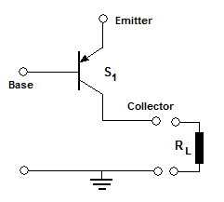
+V_{E}
V_{B} = +V_{E}
V_{C} = 0
+V_{E}

V_{B} =+V_{E} - ΔV

V_{C} = V_{E}

Fig 4.1 Cartoon illustrating the anatomy of BJT and its operation as a switching device. In the ‘off’ state, in the absence of potential difference between emitter and base pins no current flows in the device and hence no voltage falls across the load R_{L}. When the base voltage V_{B} is pulled below that of the emitter V_{E} a small base current prompts a larger collector current (indicated by orange arrows), and the V_{E} is dropped across the load.

Switching Operation of an IGBT

Although the Insulated Gate Bipolar Transistor (IGBT) is a single silicon device, its switching mechanism may be modelled qualitatively by the equivalent circuit shown in fig 4.2 [10]. The device combines the high voltage resilience of a MOSFET (Metal Oxide Semiconductor Field Effect Transistor; see [11]) with the high current capacity of a BJT. Unlike BJTs, MOSFETs are controlled by voltage on an input terminal – the gate – which is electrically isolated from the remainder of the circuit. Below a threshold gate voltage (typically ~5V) the remaining terminals – ‘source’ and ‘drain’ - are insulated from one another, but a conducting path is formed once the gate threshold is exceeded. In the IGBT this behaviour is exploited to switch high voltages as follows:

- When the gate voltage V_{G} is below threshold, the MOSFET is insulating and no voltage is dropped across the BJT base/emitter junction – no current flows and the switch is ‘off’
- When V_{G} exceeds threshold, the MOSFET becomes conducting and the drain, and hence the base of the BJT, are pulled to ground. Base current now flows and so a large collector current flows to ground – the switch is ‘on’

(a) IGBT ‘Off’ state
(b) IGBT ‘On’ state
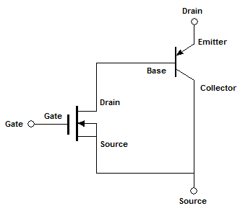
V_{D}

V_{D}

V_{G} < V_{critical}

V_{G} > V_{critical}

V_{D} - V_{S}

V_{S}

V_{S} = V_{D}

Fig 4.2 Simple IGBT equivalent circuit. The box distinguishes between the physical pins of the IGBT and the model we use to rationalise its behaviour. In the ‘off’ state the source/drain of the MOSFET are open circuit, and so the full (V_{D} - V_{S}) falls across the device. In the ‘on’ state the electrically insulated gate circuit triggers conduction in the MOSFET and hence current flows through the BJT. The large collector current facilitated by the BJT behaviour enables IGBTs to behave as short circuits even under very high (kV) voltages.

4.2 Circuit Design and Construction

As illustrated in fig 3.2 the NIKHEF design combines a BJT and IGBT to facilitate an overall voltage gain of ~100 with an input pulse of a few Volts. The complete circuit diagram used in the NIKHEF system is shown below (fig 4.3).

Fig 4.3 Complete circuit diagram of the NIKHEF IGBT amplifier. The active components –BJT and IGBT – are denoted S₁ and S₂ respectively and switch voltages V₁ and V₂ to the input of the following stage of the circuit. Regions of the circuit highlighted in blue are surge protection features designed to hold the circuit within the 0 to V₁ operational range of the transistor or 0 to V₂ range of the IGBT.

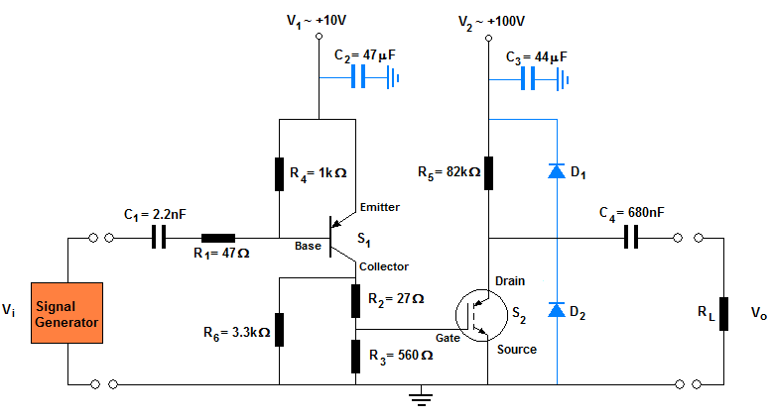

This circuit operates as follows. In steady state both base and emitter of the BJT sit at equal potential V₁ and, as described in Section 4.1, S₁ is therefore ‘off’. When the negative triggering pulse depresses the base voltage the switch is activated and the BJT will drop V₁ across resistors at the collector. This voltage step is incident on the gate of the IGBT, S₂, which switches to its ‘on’ state if the threshold voltage is exceeded. The IGBT now discharges C₄, transferring a step change in voltage to the load R_{L}. When the input square pulse returns to its off state BJT base current is extinguished and both devices return to their ‘off’ states.

The successful execution of this process depends crucially on the resistances and capacitances across the circuit, as well as the voltages at which we operate the system. Clearly components are selected with suitable tolerance levels, and provisions made to ensure unwanted voltage and current spikes are damped quickly. To this end two diodes are included at the IGBT collector to ensure it is never lifted significantly above the supply voltage or below ground. Similarly, large (~10μF) capacitors C₂ and C₃ are connected to protect the supplies from rapid voltage spiking characteristic of pulsed electronics. Low value resistors are chosen, R₁ and R₂, to limit the inrush current to the BJT and IGBT. Most importantly however, large (kΩ) choking resistors, R₄ and R₅, prevent the supplies from shorting to ground when the switches become conducting.

To ensure fast switching, BJT and IGBT are selected with appropriately short rise times – ~40ns [12] and ~20ns [13] respectively. This IGBT has a rated gate threshold voltage of 5.6V and the BJT must be able to switch well in excess of this value. Finally the BJT datasheet [12] indicates that 0.02A is a comfortable collector current. Resistors R₂, R₃ and R₆ are therefore selected to total 500Ω to permit a 0.02A collector current at 10V and we will power the BJT at just above this threshold.
4.3 Assembly and Testing

Armed with a good understanding of the NIKHEF electronics I set about assembling the circuit. Using a copper track ferroboard and taking care to isolate regions of the board at ~100V from those of the ~10V by removing several copper tracks, the circuit was assembled in a compact but accessible arrangement to allow for ease of transport and simple access for maintenance and experimentation. The finished circuit board (fig 4.4b) is mounted within a plastic box to provide adequate insulation and resist physical damage.

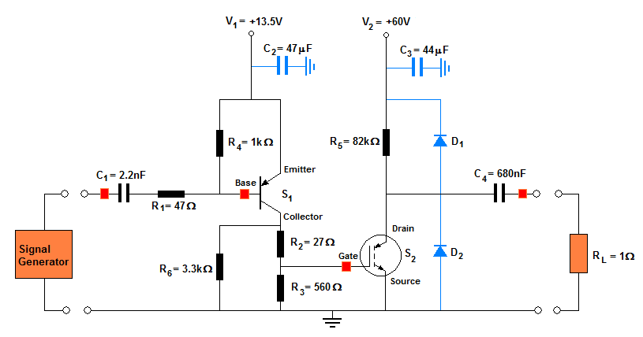
(1)
(2)
(3)
(4)
(a)
V_{o}
V_{i}
~-60V
~1V
Probe points

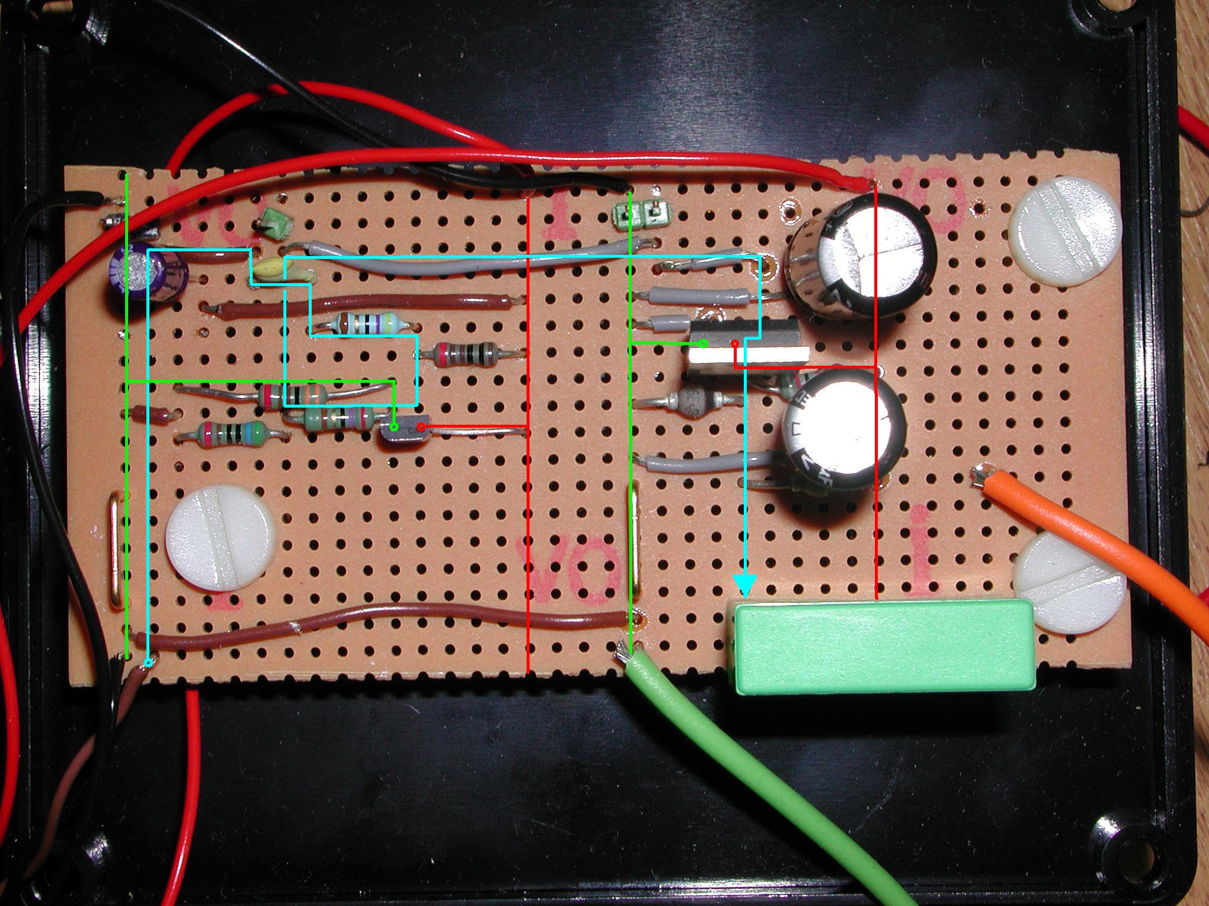
(b)
+13.5V
+60V

To Load
Signal Input from signal generator

Fig 4.4 The completed IGBT circuit (b) is pictured alongside its circuit diagram (a). Key components, the two voltage supply rails and input/output terminals are highlighted. Note that components along the same vertical strip are connected by printed copper tracks on the reverse of the board. The +13.5V rail is isolated from the 60V region of the board by three vertical rows, each of which has its copper track removed to prevent unwanted sparking when the secondary rail is ultimately operated at ~180V. Probe points are indicated and numbered in (a), covering the complete signal path indicated in (b) by the blue trace. Grounded tracks are indicated in green.

With the hardware in place a sequence of experiments were undertaken to assess the general response of the system. The relevant experimental setup is shown above (fig 4.4a). The input pulse - which will ultimately arrive from the coincidence circuitry (fig 2.2) - is simulated using a signal generator and the circuit is pulsed at 1Hz – a typical sparking rate for a small spark chamber. For simplicity a purely resistive load was selected and a low value of 1Ω chosen to simulate the low resistance of the transformer primary which will ultimately load this circuit. Care was taken to select appropriately thick load leads (visible in fig. 4.4b) as we expect instantaneous currents of tens of amps as C₄ discharges through this 1Ω. Suitable voltage supplies were selected and the lower voltage rail set at +13.5V – a trade-off between faster transistor switching time [12] and the 16V voltage rating of capacitor C₂. The higher voltage rail will be operated at +60V – significantly larger than 13.5V but ‘safe’ for tabletop experimentation.

The circuit will be probed at four key locations shown in fig 4.4 to image the pulse evolution. High impedance 1MΩ probes were selected and operated at maximum attenuation to minimise their influence on the circuit behaviour. The input pulse width is selected at 100ns – a desirable upper limit for the total rise time of this circuit. Preliminary work suggests a 0.5-2V range of input amplitudes will be sufficient to observe behaviour between BJT operational threshold and saturation - i.e. when the full supply voltage is switched - within the crucial 100ns.

4.4 Observations and Discussion

Threshold Voltages and Rise Times

With both amplifying rails held at constant potential (+13.5V and +60V) the amplitude of our 100ns input pulse was varied continuously across the 0.5-2V range of interest. Two important thresholds are identified, corresponding to the switch on voltages of the two amplifying components – the BJT and the IGBT. Images of the behaviour at probe points (1)-(4) are shown below (fig 4.5 and 4.6), illustrating behaviour around these thresholds. Note that in these figures each trace is AC coupled and so although true changes in voltage are observed, no absolute voltages are recorded.

Fig 4.5 System response at low (<1.2V) pulsing amplitude

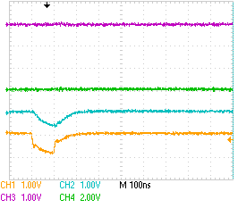
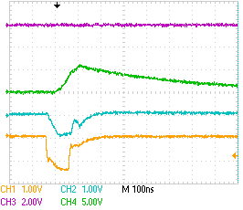
3. IGBT Input
4. IGBT Output
2. BJT Base
1. Input Signal

130ns
6V

0.6V
0.9V

0.8V
1.2V

(a) At low amplitude V_{i} <0.8V pulsing at the input, although a small 0.6V signal appears at the BJT base, it remains inactivate and the remainder of the circuit is undisturbed.
(b) At input voltages 0.8V<V_{i} <1.2V the BJT turn-on threshold is exceeded and voltage is dropped across the IGBT gate. Up to 6V at the gate fails to activate the IGBT.

A cursory glance at fig 4.5 instantly offers some general insights into the performance of our system. Firstly, notice that the ‘square’ wave applied to the circuit by the signal generator is significantly distorted, and becomes even more so by the BJT input. Between voltage steps this distortion is exponential in form, and can be related to the parasitic capacitance of our components, as will be discussed shortly. In addition to these general observations, fig 4.5a images the BJT switch on voltage at ΔV_{b} = -0.6±0.05V, where the uncertainty is determined by variation observed in consecutive experiments. Above this threshold, the BJT drops voltage at the IGBT input (fig 4.5b) which increases with increasing ΔV_{b}, consistent with our BJT theory (section 4.1). Note that at these low input voltages the BJT rise time is a relatively long 130ns. Further increase in input pulse is imaged below (fig 4.6):

Fig 4.6 System response at high (>1.2V) pulsing amplitude
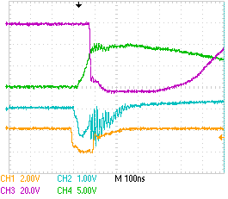
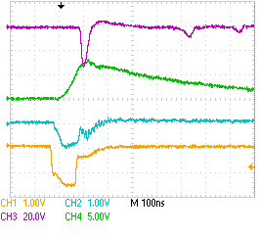
3. IGBT Input
4. IGBT Output
2. BJT Base
1. Input Signal

60V
10V
6V

2V
1.5V
80ns

(a) At V_{i} > 1.2V the BJT raises the IGBT gate above its 6V threshold voltage, and we see a brief 20ns IGBT output response.
(b) At V_{i} >2V the BJT rises to saturation within the 100ns input pulse. The IGBT is successfully activated within this rise time, switching -60V after 80ns. Note that the BJT remains saturated for a few 100ns before relaxing towards its unperturbed potential.

We see IGBT response for the first time in fig 4.6a. The 6±0.5V peak observed at the IGBT input in fig 4.5b therefore indicates a switch-on voltage, and the uncertainty is estimated by comparison with fig 4.6a and b and reflects the natural variability of the device. It is interesting to note (fig 4.6a) that activity at the IGBT output is relaxes after only ~20ns – a good 50ns before the input voltage has fallen beneath this 6V threshold, indicating more complex semiconductor physics than is considered here. Finally we see in fig 4.6b that further increase of potential difference at the BJT base, raises the BJT output to saturation at 10V - reduced somewhat from the expected 13.5V supply by the internal resistance of the device and the potential divider circuit at the collector. Crucially, the IGBT is now switches the full 60V dropped across it by the supply as predicted in Section 4.1. The overall switch on time of the system is now reduced to 80ns as indicated in fig 4.6b, and this operation demands an input pulse of 2V.

The sequence of thresholds identified above indicates that this 80ns delay is acquired in two distinct phases. The first is a rise time associated with the base of the BJT at it falls to beneath its 0.6V threshold. On careful inspection of fig 4.5b and 4.6 we find that, although this delay decreases as input pulse amplitude increases, the gains are only a few ns and the BJT rise is always initiated within 30ns. Larger gains are made in the BJT rise time. We observe that the threshold voltage of the IGBT, attained 100ns after BJT activation in fig 4.6a, is reduced to 60ns in fig 4.6b as the input pulse is increased from 1.2V to 2V. As discussed in Section 4.1 the amount of collector current delivered by a BJT is roughly proportional to the amount of base current flowing in the device. The observed improvement in rise times with increasing input pulse may therefore be understood qualitatively – as the larger input pulse drives the base voltage lower, more base current flows in the BJT, releasing larger collector current to charge the IGBT input to the 6V threshold more rapidly. Though we will satisfy ourselves with 80ns IGBT activation time for now, it is worth noting that there is still room for fine tuning here – indeed the BJT data sheet [12] suggests that under ideal conditions the rise time may be reduced to <20ns.

Relaxation Time, Repetition Rate and the RC time

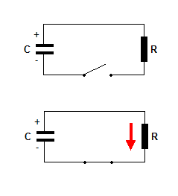
Considering primarily the system switch-on time, the relaxation behaviour of our devices also imaged in fig 4.5 and 4.6 has thus far attracted little attention. As noted above, all the transients observed in these images take exponential form. The origin of this behaviour can be traced to the interaction of capacitances and resistances across our circuit.
Fig 4.7 A fully charged capacitor (a) with initial voltage V₀ is discharged (b) through a resistor R. At the instant the switch is closed conventional current I₀ flows through R.
(b)
V₀
V₀
I₀
(a)

Let us consider the behaviour of a capacitor in the simplest physically meaningful situation – discharging through a resistor (fig 4.7). How quickly will the capacitor reach deplete its charge Q₀ and voltage V₀? After the switch is closed, the capacitor drives current I(t) through the resistor as shown. The instantaneous voltage across the resistor is given by Ohm’s law:
V(t)
V₀
Q(t)
Q₀
(a)
(b)
, Q₀

V_{R}(t) = I(t)R {1}

The instantaneous voltage across a capacitor is given by the familiar relation:

V_{C}(t) = Q(t)/C {2}

where the capacitance C is a constant depending only on the device geometry. Using {1} and {2} we apply Kirchhoff’s law – that the algebraic sum of the voltages around a circuit must be zero - and make the substitution I(t) = dQ(t)/dt:

V_{R}(t) + V_{C}(t) = 0
I(t)R + Q(t)/C = 0
1 dQ = - t dt
Q(t) RC

This simple differential equation has an exponential solution which may be expressed in terms of instantaneous charge or (applying {2}) voltage across the capacitor:

Q(t) = Q₀ e{-t/RC} or V(t) = V₀ e{-t/RC} {3}

We have therefore identified an exponential decay with a characteristic timescale τ = RC, after which any capacitor will be discharged to 1/e of its initial charge and voltage. It is straightforward to show that charging a capacitor through a resistor using an ideal voltage source returns the same time constant.

All the exponential transients of fig 4.5 and 4.6 may be understood in terms of this powerful, simple physical insight. Let us take the clearest example – the relaxation rate of the IGBT input in fig 4.6a. Although the IGBT data sheet fails to specify an input capacitance, a range of commercial IGBTs of similar specifications have rated input capacitances between C_{i}=3nF and C_{i} = 500pF across their gate and source pins. Careful inspection of our circuit diagram (fig 4.3) indicates that once the BJT switches off an RC circuit is established across R₃= 560Ω as shown in fig 4.8a. We thus expect an e-folding time τ = RC between 1.7μs and 280ns. Comparison with experimentally observed 520ns (fig 4.8b) is favourable - this decay time indicates an IGBT input capacitance of ~0.9nF, towards the lower end of the suggested values, but clearly a reasonable figure.
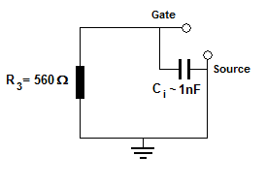
V_{Gate}
520ns
Fig 4.8 (a) Diagram indicating the RC circuit formed by the IGBT input capacitance C_{i} and the 560Ω resistance R₃. (b) The delay time required for the IGBT input voltage (green trace) to decay to 1/e of its full value is measured at 520ns.
(a)
(b)
IGBT

We can helpfully apply the RC theory to identify the slowest transient response in our system – behaviour which ultimately limits the maximum repetition rate of our system. Looking over our circuit (fig 4.3) we expect the 82kΩ of R₅ and the 680nF of C₄ to have the largest RC time as C₄ is recharged by the supply. We find that the 55.7±2ms - limited by the few percent uncertainties of our components values - is completely consistent with the 55.7±1ms ms recharge time of the IGBT determined by careful probing, and imaged below (fig 4.9).
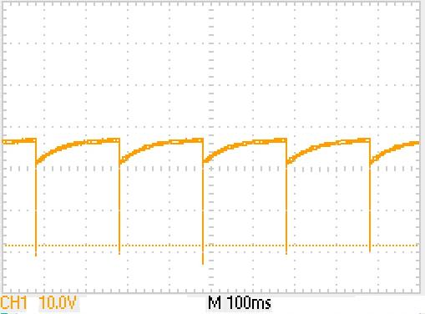
~ 56ms
Fig 4.9 Observations at the IGBT output reveal that the relaxation behaviour of the system is ultimately limited by the recharge rate of capacitor C₄. At the pulsing rate of 5Hz shown here, it recharges almost completely before each pulse. However, with an e-folding time of ~50ms we might expect a limiting repetition rate of ~20Hz.

Not only is fig 4.9 a fine example of the predictive power of RC theory, that the relaxation time of the system is >50ms is an important observation for two reasons. Firstly, this figure suggests an upper limit on the system repetition rate of 20Hz – assuming a single e-folding time is adequate to restore sufficient charge for successful sparking. After further experiment we find the true limiting rate to be ~10Hz, equivalent to two e-folding times of the RC recharge – at higher rates pulses are missed in plots similar to fig 4.9. The second important conclusion we may draw from this 50ms relaxation time is that similar relaxation behaviour elsewhere in the circuit (e.g. those observed in fig 4.6 and 4.7) occurs effectively instantaneously - 520ns relaxation of the IGBT gate is over 100,000 times faster than this 56ms recharge time. This observation is consistent with the RC times of all other capacitor and resistor pairs in the circuit, and is a reassuring indication that the circuit will be completely at rest before each pulse, if operated at <10Hz.

