Construction and Evaluation of a Fast Switching Trigger Circuit for a Cosmic Ray Detection Spark Chamber

Candidate Number: 8261R Project Supervisor: Dr. Lester

- ABSTRACT

A pulsing circuit is designed and constructed capable of raising up to +6.7kV between plates of a small (~50cm side length) spark chamber. The device is triggered by the ~2V output of a cosmic ray detection device, and its overall gain of ~1:3000 is achieved by a sequence of amplifiers and fast switching devices – namely a Bipolar Junction Transistor (BJT), Insulated Gate Bipolar Transistor (IGBT), 1:53 gain pulsed transformer and a triggered spark gap. The qualitative response of each component is assessed with respect to its response and relaxation time. The overall delay time between electronic input and this 6.7kV pulse is found to be as short as 580±100ns. The response of the electronics is investigated under a range of square input pulse amplitudes and durations, simulating input pulses expected from the cosmic ray detector. A pulse shape of 200ns and depth of 2V or more is found to minimise rise times within limits set by adjacent components. The majority (over 60%) of the overall rise time is identified with the LC charging of the step-up transformer. The 55.7±2ms RC recharge time of the capacitor driving the transformer input limits the system’s maximum repetition rate to ~10Hz. It is found that the assembled system is compatible with operation of a small spark chamber, and recommendations are made regarding further fine tuning and potential future challenges.

- INTRODUCTION

Though the era of the spark chamber as the workhorse in particle detection of the 1960s has passed, it is remembered for its elegant design and dramatic visual impact. The device discharges a sequence of alternating high and low voltage plates along the ionised track left in the wake of a passing charged particle – illuminating its trajectory with a sudden arc of light (fig 2.1a). Though solid state devices have become the research tool of choice, the spark chamber has now assumed an educational role. In an ongoing outreach project for Cambridge High Energy Physics, we seek to construct a portable spark chamber to visualise the passage of cosmic rays in real time, highlighting the frequency and distribution of this “rain” of charged particles. For both particle physicist and non-physicist alike the spark chamber brings to life both these extra-terrestrial particles and an ingenious tool from the history of detector physics.

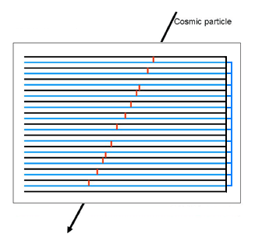

~8kV
(a)
(b)
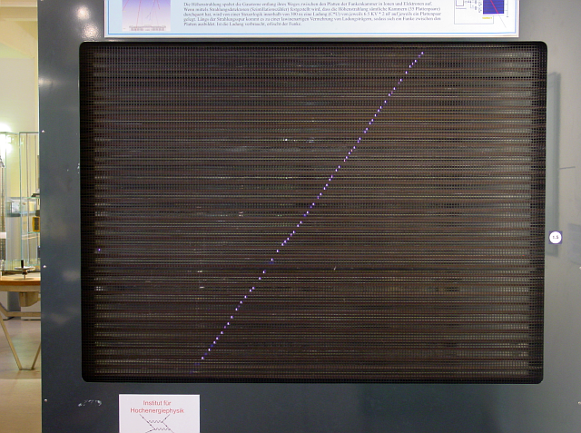

Fig 2.1 (a) Photograph of sparking in Vienna’s Technisches Museum’s spark chamber, alongside a simple cartoon (b) illustrating the track formation process. The cosmic particle ionises gas as it passes, providing a path of least resistance for discharge between adjacent plates.

The discharge between adjacent plates which ultimately illuminates the cosmic track (fig 2.1b) is of course the final stage of a sequence of key operations required for successful chamber operation. Crucially, to prevent continuous discharge between chamber plates (arcing) a triggering device must be included to apply 8kV only immediately after an ionising particle has traversed the chamber. The complete operational sequence therefore includes an event counter and pulsing circuit as illustrated below (fig 2.2), which operate as follows: (1) scintillator counters above and below the chamber detect passing charged particles; (2) coincident arrivals are isolated electronically; (3) the coincidence signal is amplified, triggering discharge across a spark gap; (4) shorting at the spark gap discharges capacitor C and drives chamber plates to high voltage; sparking in the chamber grounds all the plates and C recharges through choking resistors R₁ and R₂.

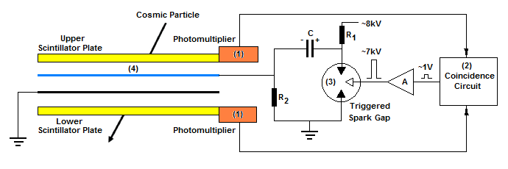

Fig 2.2 The simplest equivalent circuit completely describing the operation of a spark chamber. For simplicity only two plates are included. Labels (1) to (4) indicate the location of the processes detailed in the text above leading from detected particle to successful sparking.

In this report I shall assemble and evaluate the triggering electronics to connect stages (2) and (3) of existing hardware. The circuit is tuned to achieve the fastest overall switch on time, since high voltage must be applied to the chamber plates before the residual ionisation introduced by the cosmic particle becomes too diffuse to nucleate successful sparking. Previous work with chambers of similar dimensions to our ‘table-top’ design ([1], [2]) suggests that 100% efficient sparking can be expected if the total electronic delay between detection of a cosmic particle and application of an ~8kV pulse to the chamber is below 500ns, falling to 85% by 600ns. Assuming the coincidence circuit can be tuned to achieve <100ns rise times [3] we therefore aim to limit the overall delay time introduced by our pulsing system - which will ultimately activate the chamber plates - to better than 500ns. We will also consider carefully the relaxation time of our system to ensure that a sparking repetition rate of >10Hz is attainable – achieving a resolution of <0.1s between individual sparks. This threshold is selected as it is at the limit of the human eye and hence a sensible target rate for our demonstration chamber.

- THE SYSTEM

3.1 Triggering a Spark Chamber

Triggering a fast rise time ~500ns, high voltage ~8kV pulse across plates in a spark chamber is often achieved using a cascade of fast switching devices as shown in fig 3.1. At each stage in the circuit a switching device holds off a high voltage plate of a capacitor, which becomes shorted to ground when a triggering pulse stimulates breakdown of the device. This voltage step is conveyed across the capacitor to the input of the following switching device, and ultimately to the plates of a spark chamber. Traditionally thyratrons or triggered spark gaps are selected as switches, combining high breakdown voltages and ‘instant’ ~20ns [4] turn on time. Today solid state devices are also able to switch high voltages suitably swiftly and are preferentially used where possible due to their superior durability.
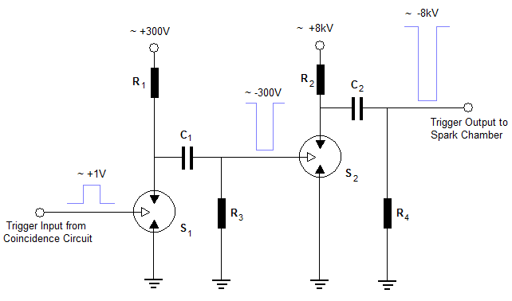

Fig 3.1 A generalised fast switching, high voltage circuit suitable for pulsing a small spark chamber. A small trigger pulse breaks down S₁, discharging C₁ to ground. This ~ -300V step is transferred across the capacitor C₁ and triggers S₂, repeating the process at higher voltages. When C₂ is fully discharged conduction in S₂ is extinguished and C₂ recharges rapidly through R₄ – switching off the ~8kV pulse that is delivered to the spark chamber.

The choice of switching device will critically affect the overall delay time of our pulsing circuit. The strength of the spark gap approach to triggering is its speed – in a research grade chamber four or five spark gaps are typical, with overall delay times as little as 100ns [4]. However both spark gaps and thyratrons are prone to deterioration on inconveniently short timescales¹ - of order 10⁵ pulses, equivalent only to ~5 days of 1Hz pulsing typical of small spark chambers. Although solid state alternatives are considerably more rugged, they too have distinct disadvantages. Even the fastest BEHLKE devices have delay times of >120ns [5], so a cascade of such devices is clearly unfeasible. To custom design a single device for the process is course expensive (~£1000). The commercially popular high voltage switching Insulated Gate Bipolar Transistor (IGBT) is both cheap and fast – capable of switching a 1kV pulse in a few tens of nanoseconds – but readily available models are limited to below <2kV operation [6].

3.2 Our Design

Appropriate hardware for our pulsing circuit must meet the following criteria:

- The circuit should deliver >8kV within <500ns of an input signal, and accommodate a 10Hz repetition rate.
- Equipment must be compact, lightweight and durable to allow for easy transportation.
- Construction costs must be minimised where possible.

Ultimately we must deliver a higher voltage output than possible using cheap solid state devices alone but we wish to avoid maintenance heavy spark gaps where possible. We therefore select a compound design tested successfully in a similar educational spark chamber designed by the Dutch Institute for High Energy Physics, NIKHEF [7]. The system uses a spark gap to ultimately deliver a ~8kV pulse to the chamber, which is itself triggered at ‘low’ (~100V) voltages by an IGBT device. In the interests of durability and ease of maintenance, our spark gap is to be triggered by a simple commercial spark plug for the automotive industry. The spark plug must be triggered at high voltage (~4kV) to ensure reliable operation, and so a pulsed transformer is used to step-up the ~100V output voltage of the IGBT. Finally, the IGBT must be triggered at above its ~6V threshold voltage, and so the ~1V output of a coincidence circuit is amplified by a simple Bipolar Junction Transistor (BJT) driven amplifier. A simplified circuit diagram is illustrated below (fig 3.2):

____________________________________________
1. The triggering electrode for spark gaps collects particulates and the noble gas within the thyratron is gradually polluted by air intrusion.
1. IGBT 2. Transformer 3. Spark Gap

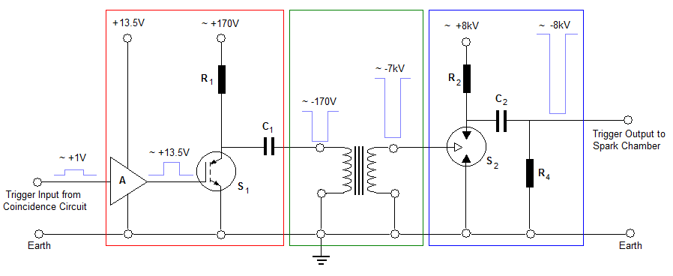
Fig 3.2 Simplified circuit diagram illustrating the primary components of the NIKHEF pulsing circuit. There are three distinct phases of amplification – a ‘low’ voltage circuit switches the IGBT, S₁; a step-up transformer; a triggered spark gap, S₂. Note that both IGBT and spark gap are driven as described in section 3.1. Stages of amplification are indicated by the evolution of a ~1V square wave to an 8kV output pulse.

The NIKHEF design is well suited for our portable chamber for a number of reasons. Although a pulse transformer is considerably slower (rise times ~300ns) than a cascade of spark gaps, it is compact, durable and need not be held at a constant high voltage. It is therefore more portable and an inherently safer system. Similarly, the IGBT is a much more convenient, reliable and inexpensive medium voltage switch than a finely tuned spark gap or thyratron. The use of a spark gap at the final stage ensures rise times of a few tens of nanoseconds on the leading edge of the pulse sent to the chamber plates – essential to avoid electrostatic dispersion of the ionised tracks before breakdown occurs [8]. In addition to physical considerations, all the components can be either manufactured on site (e.g. the transformer and spark gap) or bought commercially (e.g. the IGBT), keeping the cost of the system to a minimum (<£100). Let us now consider each section of the circuit in more detail as we set out to turn fig 3.2 into an operational triggering system.

