- CONCLUSIONS

Not only have we successfully assembled an operation pulsing circuit for our demonstration spark chamber, but with a range of experiments we have produced the following set of interesting and useful results. We have seen how initial pulsing of the circuit with a square wave of >2V is sufficient to activate the IGBT within <80ns (fig 4.6b). Furthermore, a general appreciation of the operation of a BJT suggests that this overall rise time may be reduced to as low as 50ns if the collector resistance is decreased (fig 4.3 R₂, R₃ and R₆) and/or the 13.5V primary voltage supply raised to increase the current switched by the device. We have shown in Section 5 that operation of the IGBT at >136V from the secondary supply and applying 2V, >200ns input pulses, is sufficient to ensure 100% efficient spark plug discharge within 350ns (fig 5.8). Further increasing this voltage is found to reduce this time further, though it is recommended to operate below 180V as this is the specification to which the transformer has been fabricated (Section 5).

Components across the circuit are seen to obey several key physical theories. Relaxation rates are associated with recharging/discharging capacitances around the circuit – whether dedicated components or parasitic capacitances e.g. the high input capacitance of the IGBT imaged experimentally in fig 4.8b. This theory is usefully applied to identify the limiting 55.7±2ms charge time of the IGBT circuit’s 680nF capacitor (fig 4.9) responsible for the observed ~10Hz maximum repetition rate of our complete system. The largest single source of delay in our circuit is identified as the transformer rise time, which can be understood in terms of LC charge oscillation (Section 5.4). This theory is exploited to reduce overall spark plug discharge times to <400ns. Finally, the non-ideal transformer modelled discussed in Section 5.1 not only rationalises the tight linear relationship between input and output voltage (fig 5.9) but indicates that, at operational voltages, our transformer delivers output voltages only 4% shy of ideal values – reflecting the care taken during construction.

Finally, pulsing our ‘home-made’ spark gap with the complete circuit suggests that our electronics can currently achieve overall delay times of 580ns with a distribution of ±100ns (fig 6.4) and a switched voltage of 6.7kV (fig 6.2). Ultimately this result is highly encouraging – when coupled to the ~100ns delay introduced by the coincidence circuit, we may ultimately achieve overall delay between cosmic ray detection and high voltage pulsing of the chamber plates of <600ns, for which [1] suggests a small chamber with deliver 85% efficient sparking. Furthermore, over the course of these investigations several areas have been highlighted where further fine tuning could reduce this delay time still further – the rise time of the BJT and the spark gap threshold voltage. It is the latter consideration which is of greatest concern as this report closes – we find (fig 6.2) that our spark gap can currently defend only <6.7kV. This falls short of the >8kV with which small spark chambers are traditionally pulsed e.g. [1], [19] and further work will be required to assess the implications of this limit for our system.

Electronics charging the spark gap anode plate
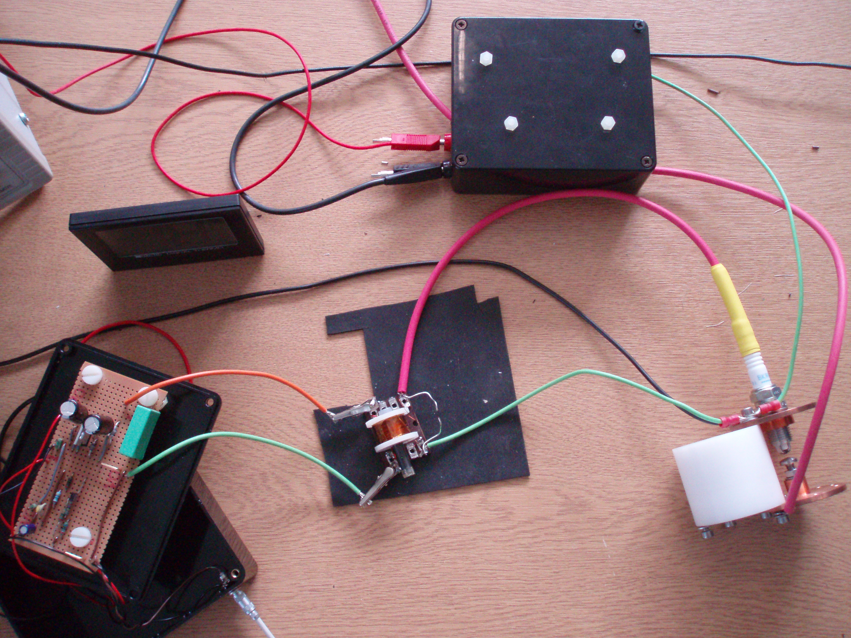

Spark Plug
Transformer (Section 5)

Spark Gap
(Section 6)
IGBT amplifier electronics (Section 4)

Fig 7.1 The complete pulsing system. Note its portable size – the field of view is ~30cm by ~50cm. In fact, the voltage supplies are by far the chunkiest aspect of the current design.

Ultimately however, we have constructed a fully functional triggering device to connect our existing particle detector to a spark chamber, still to be fabricated. The circuit is durable, and although not yet portable (see fig 7.1) it is compact enough to envisage easy attachment to a table-top spark chamber. In conclusion, not only has this project broadened my understanding of the electronics of the spark chamber, it has provided a taste of the visual excitement of a spark chamber in the successful triggering of our spark gap - I look forward to the completed chamber.

