
ATLAS TDAQ Readout

ROD Crate DAQ User’s Guide

Document Version: 1.5
Document ID: ATL-DQ-EN-0020
Document Date: 1 June-2005
Document Status: Draft

Abstract
This document is a user’s guide to ROD Crate DAQ. The architecture of the ROS/RCD (also called the IOManager framework) is briefly reviewed and the way in which the user develops detector specific configuration and readout software is explained. Several examples are described in detail. Procedures for the installation of hardware and software are provided in appendices.
Authors:
CERN – S.Gameiro, B.Gorini, M.Joos, J.Petersen
INFN – E.Pasqualucci
UCL – G.Crone
Table 1 Document Change Record
Title: | ROD Crate DAQ User’s Guide
ID: | ATL-DQ-EN-0020
Version | Issue | Date | Comment
1 | 1 | 22 February ‘05 | First attempt
1 | 2 | 3rd March ‘05 | Major restructuring
1 | 3 | 15th March’05 | Changes following developments related to Configuration. Comments from Sonia, Gordon & Markus.
1 | 4 | 17th March’05 | Changes to the Modules, Configuration and Data driven event building chapters.
1 | 5 | 1st June ‘05 | Review section on plugins. Add User Action Scheduler

Introduction
After the 2004 combined test beam and the ROD Crate DAQ (RCD) workshop in November 2004, a document was written proposing a further generalisation of the ROS software to include the requirements of RCD, see Ref1. A first implementation of this design is available in TDAQ release TDAF-01-01-00 which is intended to provide support for detector commissioning. This note describes the RCD software in release TDAQ-01-02-00 in which support for scheduling of user handlers has been added.

Purpose of the document
This document is a user’s guide to RCD and describes how the user adds detector specific software components to the standard ROS/RCD software available in a TDAQ release.

Glossary, acronyms and abbreviations

Glossary
Most of the terms used in this document are defined in the T/DAQ-wide glossary currently accessible at: http://mdobson.home.cern.ch/mdobson/tdaq/glossary.html

Acronyms and Abbreviations

References
Ref1: Extensions of the IOManager Architecture to ROD Crate DAQ
https://edms.cern.ch/document/554806/1
Ref2: ROSHowTo
https://edms.cern.ch/document/478664/1
Ref3: Presentation on RCD enhancements
http://agenda.cern.ch/askArchive.php?base=agenda&categ=a05688&id=a05688s1t7%2Ftransparencies%2FRCD-enhancements.ppt
Ref4: DFDebug.
See the file /doc/DFDebug.pdf in the DFDebug package.
Ref5: FSM and related methods
https://edms.cern.ch/document/431663/2.1
Ref6: Error reporting and handling in the ROS software.
https://edms.cern.ch/document/575871/1
Ref7: Description of Muon ROD test setup in CERN BB5
To be prepared

RCD use cases and requirements
The ROD Crate DAQ is used in a wide set of environments, from detector and electronics test stands to beam tests, up to detector commissioning sites and the final experiment. As a consequence, it has to satisfy a set of requirements coming from a large set of use cases. In this section, we briefly review the most common use cases and required functionalities.

Module control
Controlling one or more modules is the simplest use case for the RCD. In this case, no data readout is required, though controlled modules can be accessed during the run to get information about the status of the system. Typically, this happens when the RCD application is used to control trigger modules or to modify module state at a run state transition. Controlling ROD modules without sampling data or acquiring histograms is another typical application.
Required functionalities are:
- the ability to access the modules (in general, through the VME bus, but, in some cases, through PCI or any other communication channel);
- the ability to communicate with a controller to receive run state transition requests and send back the error state and error messages;
- the ability to access the Information Service to regularly publish the status of the system during the run (functional monitoring).

ROD emulation
The data format is the key to inject data into the Atlas TDAQ system. When the RCD is used to get data from a module or a set of modules not formatting data as ROD fragments (for instance, data is read out from a set of ADC and TDC through the VME bus), its primary task is to build a ROD fragment. This working mode is called ROD emulation.
ROD emulation is typically used when a detector ROD is not available, like in some cases during the beam tests on at some commissioning sites, or while testing a detector with simpler electronics at detector test stands.
The ROD emulation has to add some functionality to the ones needed for module control. Required functionalities are (see Error: Reference source not found):
- the ability to access the modules (in general, through the VME bus, but, in some cases, through PCI or any other communication channel);
- the ability to communicate with a controller to receive run state transition requests and send back the error state and error messages;
- the ability to access the Information Service to regularly publish the status of the system during the run (functional monitoring);
- the ability to detect the availability of data, either polling some memory location or reacting to an interrupt;
- the ability to read out data from the modules, build and format the event fragment as a ROD fragment;
- the ability to send it to an output device.
In addition, it has to provide event sampling and output sampled data to the Atlas monitoring system.

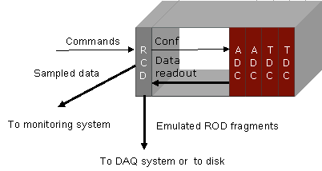

Figure 1 ROD emulation example

Using the ROD Crate DAQ for ROD emulation in the current release requires some more customization than the other use cases. This will not be described in detail in this document. For an example of an existing ROD emulation implementation please refer to document Ref7.

ROD control and data read out
This is the main use case for the phase 1 of detector commissioning, when the RCD is the DAQ tool available for detector readout. The ROD modules have to make data available through their VME interface, formatted as ROD fragments. In this case, all the functionalities described above are needed; with a difference in the output event format: the output fragment being built of ROD fragments, it is formatted as a ROS fragment. This gives the possibility of directly sending the event via a TCP connection to a Data Driven event builder (see section 2.5 and chapter 8). A mixed system building events form two RCD and a ROS is shown in Figure 13.
Required functionalities are:
- the ability to access the modules (in general, through the VME bus, but, in some cases, through PCI or any other communication channel);
- the ability to communicate with a controller to receive run state transition requests and send back the error state and error messages;
- the ability to access the Information Service to regularly publish the status of the system during the run (functional monitoring);
- the ability to detect the availability of data, either polling some memory location or reacting to an interrupt;
- the ability to read out data from the ROD, build and format the event fragment as a ROS fragment;
- the ability to send it to an output device;
- the ability to provide event sampling and to send output sampled data to the Atlas monitoring system.

ROD control and monitoring
This is the typical use case for the ROD Crate DAQ during Atlas runs. The ROD modules are fully controlled by the application, but the modules themselves manage the primary data flow, sending events to a read-out system through a read-out link. In this case, the RCD acquires sampled fragments from RODs for monitoring purposes (see Figure 3)
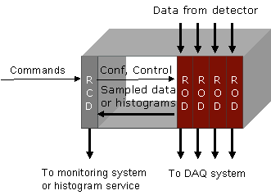

Figure 2. ROD control and monitoring

In some ROD, most of data processing can be handled by the internal processors or DSP. Sometimes, histograms are produced, and the RCD must be able to get and send them to the histogram service to be browsed or analysed.
Dealing with high rate primary data flow, event sampling, event formatting and processing, the ROD must be able to signal errors to the controlling application. The RCD has to be able to detect an error either polling on some register or receiving and catching interrupts.
In this case, required functionalities are:
- the ability to access the modules (in general, through the VME bus, but, in some cases, through PCI or any other communication channel);
- the ability to communicate with a controller to receive run state transition requests and send back the error state and error messages;
- the ability to access the Information Service to regularly publish the status of the system during the run (functional monitoring);
- the ability to detect the availability of sampled data, either polling some memory location or reacting to an interrupt;
- the ability to read out data from the ROD, build and format the event fragment as a ROS fragment;
- the ability to send it to an output device if needed (for instance, for some local analysis);
- the ability to provide event sampling and to send output sampled data to the Atlas monitoring system;
- the ability to read out histograms on regular basis (or on request) and to send the to the online histogram service;
- the ability to detect errors and deal with them, reacting according to the error severity and signalling them to the operator.

Data driven event building
In many systems, a set of data sources, either ROD modules read out via VME or ROD emulations can be combined between them or with the output from some ROS to build events from different sub-detectors or parts of them. This typically happens during the detector commissioning, when the full TDAQ system is not available, or in some test sites. In these cases, no high level trigger is required nor any load balancing functionality.
The Data Driven Event Builder, also known as ROD Crate DAQ event builder (REB) is a flavour of the readout application receiving ROS fragments from TCP connections and building complete events. This use case is described in detail in chapter 8.

RCD architecture

Trigger, Output, Module and Configuration plugins
Figure 4 shows schematically the architecture of the ROS/RCD in the form of a simplified class diagram. The core class of the system is the IOManager that provides the following functionality: control interface, error reporting, configuration, scheduling of threads etc. The ROS/RCD and in particular the I/O system can be tailored to the application via a number of plugins, see also Ref2.
- Trigger
The ROS/RCD delivers fragment data (or releases fragments) only when triggered by an external request. In the ROS/RCD, a trigger handles these requests. In a TDAQ release several trigger plug-ins are provided e.g.
  - DataDrivenTriggerIn
Receives requests from a trigger queue internal to the ROS. The trigger is generated when the fragments have arrived.
  - DCTriggerIn
Receives EB, LVL2 or CLEAR requests from the network.
  - EmulatedTriggerIn
Generates EB, LVL2 and CLEAR requests in relative ratios as defined by the user.
A user has to select the appropriate trigger plugin, in RCD usually the DataDrivenTriggerIn. The user may develop specific trigger plugins although this should be an exceptional case.

- DataOut
The ROS/RCD can output fragment data to a number of output channels. In a TDAQ release several dataOut plug-ins are provided e.g.
  - EmulatedDataOut
Sends ROS fragments to a null output or a local disk.
  - TCPDataOut
Sends ROD or ROS fragments to Ethernet.
  - DCDataOut
Sends ROS fragments to the network using DC message passing.

A user has to select the appropriate dataOut plugin, in RCD usually the EmulatedDataOut or the TCPDataOut . The user may develop specific dataOut plugins although this should be a very exceptional case.

- ReadoutModule
A module describes a hardware or software component that is controlled by the IOManager and has methods corresponding to the FSM transitions. In RCD a module typically describes a module in a ROD Crate e.g. a ROD. In a TDAQ release several ReadoutModule plug-ins are provided e.g.
  - EmulatedSequentialReadoutModule
Describes a RCD module with internal generation of ROD fragments
  - PCIRobinReadoutModule
Describes a ROBIN in the baseline ROS
  - FilarReadoutModule
Describes a Filar readout system typically used in test beam applications
These plugins are standard ROS/RCD software components and part of a TDAQ release. In RCD, the user develops module plugins (and possibly associated data channels) that are detector specific. This will be described in detail in section 4.1.
Note: the terms “module” and “ReadoutModule” are used interchangeably in the remainder of the document. The first is a more general term to describe a logical concept in the design while the second is the name of a class. Actually a somewhat misleading name since the methods in a ReadoutModule class may not implement readout functionality but only configuration.

- Configuration
Configuration parameters are transmitted to the ROS/RCD via the configuration plugin (note: this plugin was previously associated with the Local Controller). In a TDAQ release several configuration plug-ins are provided e.g.
  - RCDConfig
Reads the parameters from the configuration database using the DAL and builds Config objects (containing key/value pairs) which are transmitted to the IOManager. The RCDConfig plugin is able to retrieve parameters from a user developed database as described in section 5.3.
  - ROSAsciConfig
Reads the parameters from ASCII configuration files and builds Config objects (containing key/value pairs) which are transmitted to the IOManager
In RCD, the RCDConfig plugin covers most use cases but the user may exceptionally develop configuration plugins that are detector specific. This will be described in detail in section 5.3.

IOManager
Main Program
. Control Interface
. Error Handling
.Configuration
.Scheduling
. Event selection

<plugin>
Trigger
E.g.
DataDrivenTrigger
DCTriggerIn
EmulatedTriggerIn

<plugin>
DataOut
E.g.
EmulatedDataOut
DCDataOut
TCPDataOut

<plugin>
ReadOutModule
E.g.
EmulatedSequentialReadoutModule
EmulatedReadoutModule
FilarReadoutModule
VMEReadoutModuleUser
PCIRobinReadoutModule

<plugin>
Configuration
E.g.
ROSDBConfig
RCDConfig
ROSAsciConfig

Figure 4. IOM (RCD) schematic class diagram

Requests

Threads in the ROS/RCD
Figure 5Figure 6 shows a threaded view of the ROS/RCD. This figure is extracted from Ref3 to which we also refer for more details. The ReadoutApplication process contains a number of ‘ROS’ threads: trigger(s), request handlers and control/error handlers. The generalisation of the ROS to include RCD requirements have led to the (optional) presence of another thewo threads:
- The Sequential Input Handler
This thread supervises the input of (ROD or ROS) fragments from data sources (data channels). Fragments are read sequentially and stored in internal buffers in PC memory, labelled by their Level 1 ID. When all fragments corresponding to a given L1id have arrived, a message is sent to the Trigger (via a queue not shown in the figure) and a request is posted on the request queue. A request handler then extracts the fragments for a given L1id from the internal buffers and sends a fragment to the output channel.

- The Interrupt Handler
This thread is activated by (VMEbus) interrupts. The source of the interrupt may be e.g., error conditions, availability of histograms etc. in which case a use defined interrupt handler is activated. Or the interrupt may signal the presence of a (ROD) fragment to be read out in which case the Sequential Interrupt Handler is activated as described above.
- The User Action Scheduler
This thread supervises the execution of user handlers based on time slicing: when a time interval associated with a user handler expires, the User Action Scheduler activates the user handler. The User Action Scheduler is similar to the Interrupt Handler but driven by timers instead of external VMEbus interrupts.

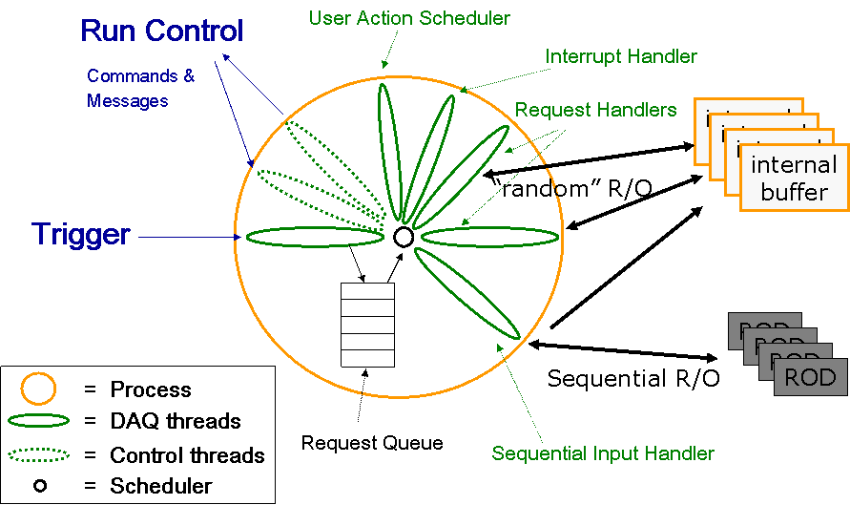

Figure 5. IOM (RCD) threaded view

Developing Detector Specific Module plugins

Modules
As explained in Ref2 a module describes a hardware or software component that is controlled by the IOManager. The ReadoutModule is an abstract base class with virtual methods for each of the FSM state transitions. Derived classes allow to define different types of modules. Some properties of modules:
- A module may perform any appropriate action on HW or SW components of the ROS associated with a state transition.
- A module may or may not be associated with the input of data (data channels, see chapter 4.2). In the first case the data channels are created in the module. The type of data channel is hard coded which implies that the relation between module types and data channel types is fixed.
In ROD Crate DAQ modules are developed by the user and derived from the ReadoutModule class. Examples of user modules will be explained in chapter 10.

Methods
The methods corresponding to the FSM state transitions are described in Ref5. An additional method, called setup, is ROS/RCD specific:
Method:
setup(DFCountedPointer<Config>configuration)

Parameters:

configuration | the Config object describing a ReadoutModule

The Config object consists of a set of key/value pairs. It includes, on one hand, keys that are common to all modules, and on the other hand, the configuration database attributes specified by the user in his module. A detailed description of the Config object can be found in section 5.3.
Description:
The setup method is the equivalent of the constructor for a module (the real constructor is called via the plugin mechanism without arguments and thus the configuration parameters cannot be passed). It is recommended that setup() would only contain code that extracts parameters from the database (via the module Config object). “Actions” should be implemented in other methods e.g. load().
Note: in the current implementation, the setup() and load() module methods are called from two consecutive lines of code in the load() function of the IOManager but this may change in the future.

Data Channels
A data channel is associated with a source of data. The DataChannel is defined as an abstract base class with virtual methods for requesting, retrieving and deleting fragments. In addition the base class contains a global vector of pointers to all data channels instantiated in the ROS/RCD (indirectly by the IOManager when instantiating the modules). Data requests operate on a subset of this global vector of data channels.
Data channels are not state aware i.e. don’t contain methods that are called by the IOManager on run state changes. However, since data channels are created by modules, methods can be added to the specific data channel implementations and called from the module when state changes occur.
Derived classes allow to define different types of data channels. A more specialized DataChannel abstract subclass is provided for RCD implementations, which describes sequential data channels. Those data channels have virtual methods for polling on a data source and retrieving data (ROD fragments) sequentially, see Ref1. shows a class diagram of the Data Channels. RCD users should implement their data channels starting from this SequentialDataChannel base class and not directly subclassing the main DataChannel class.

DataChannel

DataChannel(
id,
configId,
rolPhysicalAddress)

virtual requestFragment(l1id) = 0
virtual getFragment(l1id) = 0
virtual releaseFragment(l1id) = 0

static std::vector<DataChannel *> s_dataChannels

SpecificDataChannel

SpecificDataChannel(
id,
configId,
rolPhysicalAddress,
usePolling,
configuration,
…………)

getNextFragment(….)
poll()

PCMemoryDataChannel

PCMemoryDataChannel(
id,
configId,
rolPhysicalAddress,
configuration)

SequentialDataChannel

SequentialDataChannel(
id,
configId,
rolPhysicalAddress,
usePolling,
configuration)

virtual getNextFragment(….)
virtual poll()

Figure 7 SequentialDataChannel Class diagram

Virtual methods that the user needs to implement
Method:
int SpecificDataChannel::poll()
Parameters:
None
Description:
This function allows the SequentialInputHandler to determine if a given data channel has some new event fragments available that needs to be read out. The return code of poll() is defined to be:
Return code | Definition
0 | No new data available
1..n | 1..n event fragments are available
Errors shall be reported with exceptions.
Beware that this method has to be implemented even though you plan to only use interrupts as a mean to signal the availability of data fragments. In such a case the poll method is expected to always return 0.

Method:
int SpecificDataChannel::getNextFragment(unsigned int * memorySpace, int maxSize, int pciAddress=0)
Parameters:
memorySpace | A pointer to a data buffer for the event fragment
maxSize | The size of the buffer pointed to by memorySpace in bytes
pciAddress | The PCI address of the buffer space if needed for DMA
Description:
This method has to contain user code to read a new event fragment from a VMEbus slave module and to deposit the data in a dedicated buffer.
The method returns the size (in bytes) of the new event fragment or -1 if the transfer was not successful e.g. due to a VMEbus error.
Beware that if you plan to use interrupt as a possible mechanism to signal new events, you should make sure that any possible cleanup requested for readout related interrupts (typically writing a specific register to re-enable interrupts from the specific ROD module) is implemented here.

Public methods available to the user
Method:
SequentialDataChannel::SequentialDataChannel(
unsigned int id,
unsigned int configId,
unsigned int rolPhysicalAddress,
bool usePolling,
DFCountedPointer<Config>configuration)

Parameters:
id | The ATLAS wide ROL or ROB identifier, see Ref2.
configId | The sequential number of the channel within the module (0,1,2.. )
rolPhysicalAddress | A “physical” address associated with a channel, see Ref2.
usePolling | Defines whether the channel uses polling (true) or interrupts (false)
configuration | The Config object describing a ReadoutModule

Description:
The constructor of the SequentialDataChannel passes the parameters id, configId, rolPhysicalAddress and configuration onto the PCMemoryDataChannel. It registers itself with the SequentialInputHandler and creates the Event Input Manager and memory pools associated with the data channel., see also Ref1

VMEbus interrupt handling
The IOM framework provides a way for the users to associate an interrupt vector with a custom handler method. To specify custom handling code, the user has to create a subclass of the InterruptHandler abstract class and implement at least the abstract reactTo method (see).
As explained in chapter 3, the IOM framework creates a dedicated thread listening to VMEbus interrupts which will make sure that the appropriate handler is called when an interrupt is issued on VMEbus.
The user has the complete control on how to implement the handlers, including the responsibility of making sure that the interrupts are cleared before returning from the handler call.
In case an interrupt is used to trigger data readout, the user will only need to identify which channel is ready to provide data and then call the method signalFragmentAvailable() on the specific SequentialDataChannel instance that is related to it.
The actual data readout operation will not be executed by the interrupt handler. The handler will only schedule it so that it will later be executed by the SequentialInputHandler thread.

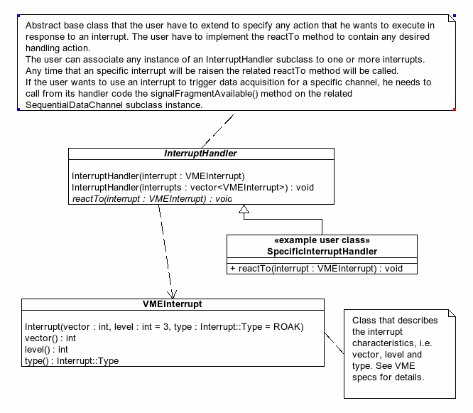
Figure 8: User perspective view of the interrupt handling architecture

Virtual methods that the user needs to implement
Method:
void SpecificInterruptHandler::reactTo(VMEInterrupt interrupt)
Parameters:
Interrupt | An VMEbus interrupt descriptor
Description:
This method has to contain the user code to fully handle a VMEbus interrupt.
If the interrupt was not issued to signal the availability of a new fragment for readout the reactTo method should implement any possible user defined action. E.g. if the interrupt signals that a ROD has filled a histogram the user code has to allocate space for the histogram, execute the VMEbus cycles to transfer the histogram data into the local buffer most likely publish it to the OH.
If instead the interrupt signals the availability of new data, the user code shall not implement any data transfer functionality, but should only call the signalFragmentAvailable() method on the concerned DataChannel instance. Data readout will be scheduled by another IOManager thread whenever appropriate.

Public methods available to the user
Method:

VMEInterrupt::VMEInterrupt(int vector,
int level=3,
VMEInterrupt::Type type=ROAK)

Parameters:

vector | A 8 bit VMEbus interrupt vector
level | A VMEbus interrupt level from 1 to 7
type | A VMEbus interrupt type (supported values are: ROAK, RORA)

Description:
This constructor creates a specific VMEbus interrupt descriptor.

Method:
InterruptHandler::InterruptHandler(VMEInterrupt interrupt)
Parameters:
interrupt | A VMEbus interrupt descriptor
Description:
This constructor associates the InterruptHandler instance with one specific VMEbus interrupt descriptor.

Method:
InterruptHandler::InterruptHandler(vector<VMEInterrupt> interrupts)
Parameters:
interrupts | An array of VMEbus interrupt descriptors

Description:
This constructor associates the InterruptHandler instance with a group of VMEbus interrupt descriptors.

Method:
void SequentialDataChannel::signalFragmentAvailable()
Parameters:
none
Description:
This method increases the internal counter of fragments waiting to be readout. It is supposed to be called by a user defined interrupt handler.

Scheduling of User Handlers
The IOM framework provides a way for the users to define a custom handler that should be scheduled when a time interval has expired. To specify custom handling code, the user has to create a subclass of the ScheduleUserAction abstract class and implement the virtual reactTo method (see Figure 9).
As explained in chapter 3, the IOM framework creates a dedicated thread which will schedule the appropriate handler when the user defined time interval has expired. The calculation of the time interval is based on the ROS time stamping library (and not on system timers) which implies that the time intervals have a certain distribution (note: Linux is not a “hard” real-time system, it’s never guaranteed that user handlers activated via VMEbus interrupts or time scheduling will be executed within a given time).

Abstract base class that the user will have to extend to specify any action that he/she wants to execute when the specified time interval expires, via the virtual reactTo() method.
ScheduledUserAction
ScheduledUserAction (unsigned int deltaTimeMs)
void reactTo (void)

<example user class> specificScheduledUserAction
+void reactTo (void)

Figure 9: User perspective view of the handler scheduling architecture

Virtual methods that the user needs to implement
Method:
void SpecificScheduledUserAction::reactTo(void)

Parameters: None
Description:
This method contains the user code to be executed periodically. As an example (RODBusy): the method reads a FIFO with busy counters and updates histograms. The latter may be published via the probe() or publishFullStatistics() mechanisms or may be sent directly to the Online Histogramming system.

Public methods available to the user
Method:
ScheduledUserAction::ScheduledUserAction
(unsigned int deltaTimeMs)
Parameters:

deltaTimeMs | Number of milliseconds between scheduling of handler. deltaTimeMs = 0 means: schedule as fast as possible (“infinite” frequency)

Description:
The constructor registers the handler(or UserAction) with the UserActionScheduler thread and defines the time interval associated with this handler.

Method:
unsigned int getLastTimeSlice()
Parameters:
none
Description:
This method returns the length the last time slice.
Note:
The time slicing is based the time stamping library and consequently there are variations in the length of the time slices.

Error Reporting & Exceptions
In ROS/RCD, messages and in particular error messages can be output using the stream: dfout. To use it one has to include “DFError/DFOutputStream.h” and link with libDFErrorHandling (which most ROS/RCD libraries do). The advantage of using this stream is that the output destination can be configured dynamically. When a library using the dfout stream is linked in the IOManager/Control/GUI context all messages will go to the controller and be forwarded to MRS and the IGUI. If used in a simpler context, the messages will simply go to stdout.
In the ROS/RCD, errors conditions are reported and handled via exceptions. For some errors, typically “serious” ones, an exception may be thrown which implies that the execution flow is broken. An error catcher may analyse the error and decide whether the error is fatal in which case the process (thread) is stopped or recoverable in which case the execution may resume after the error has been handled.. An exception may also be notified i.e. reported to the user in some way but allowing the program to continue the execution. The notification is implemented using the dfout stream which has methods for outputting the information embedded in an exception, see the next section.

Message and Error reporting
To send a simple message you just do
dfout << "whatever simple message" << endm;
Please note the terminating endm. This stream is indeed message oriented, which means that the stream will only be flushed upon reception of an end modifier. If you forget to send endm, all your information will be kept in the stream internal buffer and only sent whenever an endm modifier is sent to the stream from any other place in the code!
Like MRS the stream has the concept of a message severity. The available severity levels are listed in DFError::Severity enumerator: enum Severity {UNCLASSIFIED, EOR, DEBUG_INFO, INFO, WARNING, RECOVERABLE, FATAL}. You might note that for compatibility reasons those levels exactly match MRS ones. By default simple messages are considered to be of DFError::INFO severity. Of course you might want to redefine what the severity of your message should be. The stream thus provide a specific modifier: setseverity(DFError::Severity). Here is an example of how to use it:
dfout << setseverity(DFError::DEBUG_INFO) << "whatever message" << endm ;

In a ROS context, real error messages also carry extra information (a numerical code, and a string defining the originating package name). Code and package name are defined inside specific package exception classes. Thus when an error occurs the exception class is instantiated and notified to the error reporting system through its notify() method. To ensure compatibility with this approach the stream offers another modifier: setexception(std::exception). So if you have an exception e that you want to notify to the error reporting system you just do:
WhateverPackageException e(WHATEVER_ERROR);
dfout << setexception(e) << endm;

If the exception is a standard ROSException the stream will extract the error code and the package name from it, in addition to the error message.
Whenever you use the setexception modifier the default severity of the current message will be set to DFError::RECOVERABLE. This default can always be redefined using the setseverity modifier. E.g.:
WhateverPackageException e(WHATEVER_ERROR);
dfout << setseverity(DFError::WARNING) << setexception(e) << endm;

Whenever you use the setexception modifier the message contained in the exception will be extracted and concatenated with whatever other string you send to the stream before the endm modifier. This allows you to qualify better the basic exception message. E.g.:
//Create an exception for a "file not found" error
WhateverPackageException e(FILE_NOT_FOUND);
//Specify the error message with the specific file name
dfout << setexception(e) << ": file foo.txt" << endm;
The resulting message will be the concatenation of the standard message associated to the error (i.e. "file not found") and ": file foo.txt" that specifies what specific file could not be found. Hence the complete error message will be "file not found: file foo.txt".

Exceptions
The use of exceptions for error reporting and handling in ROS/RCD is described in Ref6. This document contains a section “Implementation guideline” which the developer of a detector specific module may follow to implement error reporting and handling . See also section 10.1.1 for an example.

Configuration
This chapter explains how to access the configuration of a Readout Module from the database, and in which way it is available for the user in the specific readout module plugin.
The general configuration plugin, called RCDConfig, is in charge of reading the parameters of the Readout Module from the database and putting them in a Config object. This Config object will be passed as an argument to the setup() method of the ReadoutModule, as explained in section 4.1.1.
The first step in the configuration process is to create a new schema that includes the definition of the new ReadoutModule class (which we will refer as MyReadoutModule) and its corresponding parameters.

Creating a new schema
Readout Module parameters can be mainly attributes (such as the base address of the VMEbus module, whether polling or interrupt is used…) or relationships to other classes in the database.
Once the new Readout Module parameters are defined, a new schema needs to be produced. The user defined classes will remain in separate schemas from the general ones (df.schema.xml and core.schema.xml), and need to be included directly in the partition.
The user can use an empty schema file which can be found at the RCDExampleConfiguration package, schema directory: EmptySchema.schema.xml. It should be copied locally, renamed, and edited with oks_schema_editor. Figure 10 shows the resulting panel.
> oks_schema_editor MySchema.schema.xml

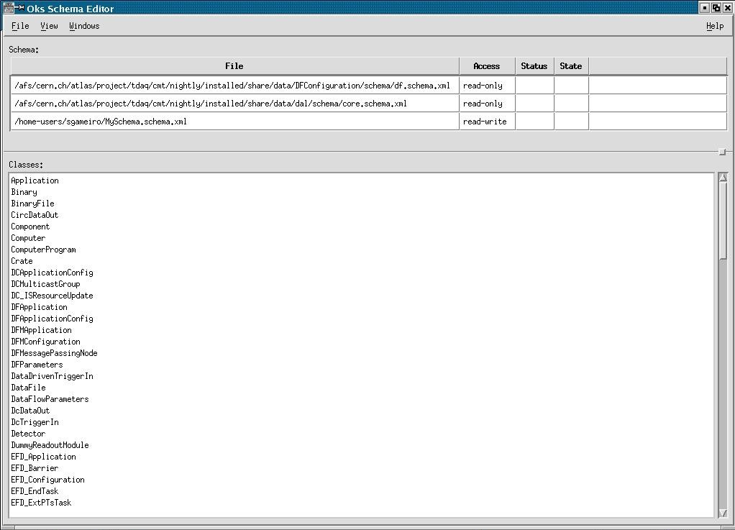
Figure 10: oks_schema_editor panel when editing MySchema.schema.xml.
This schema includes the two general schemas: core.schema.xml and df.schema.xml, but it has no classes included. First set MySchema “active” in the list of files on top, by selecting it and choosing this option with the mouse right button.
Add the new ReadoutModule class doing “New” with the mouse right button in the main window. Include in the All Super Classes field the class ReadoutModule, and add the class specific attributes and relationships in the corresponding fields. Save and exit. An example of a newly created ReadoutModule is shown in Figure 11.

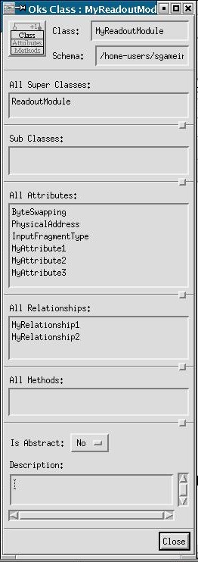
Figure 11. Example of user ReadoutModule class

0 shows an instance of the MyReadoutModule class.

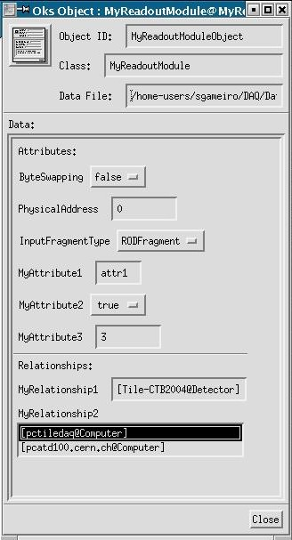

Figure 12 – Instance of a MyReadoutModule class.

As can be seen in , the MyReadoutModule class has six attributes, the first three are inherited from the base class ReadoutModule, and the other three are of type “string”, “bool” and “u32”. It also has two kinds of relationships:
- MyRelationship1, with cardinality 1 and type “Detector”
- MyRelationship2, with cardinality “zero or many” and type “Computer”.
This example will be used further on to illustrate the parsing of relationships in the database.

Accessing the Readout Module parameters
The setup() method of the Readout Module receives as an argument a Config object. This object contains a set of keys that are common to all the Readout Modules, and in addition all the attributes specific to that ReadoutModule.
Here is a list of the common keys inside the Config object:
Key Value
“configurationDB” a pointer to the global database. Allows the user to access the global database from the code in the module.
“appName” name of the application (as defined in the database)
“UID” the Readout Module object identifier (e.g. “RCD-54”)
“ByteSwapping” boolean that specifies if byte swapping is done or not
“PhysicalAddress” in case the user wants to associate a physical address to the module
“InputFragmentType” specifies whether the module receives ROD or ROS fragments (only relevant when using data driven event building, see Chapter 8).
Concerning the specific Readout Module attributes, the following table shows all the possible attributes’ type, and the method of the Config class used to retrieve each one of them.

Attribute Type | Retrieve from Config with
Bool | getBool()
s8, s16, s32 | getInt()
u8, u16, u32 | getUInt()
Float | getFloat()
Double | getFloat()
Date | getString()
Time | getString()
String | getString()
Enum | getString()

In addition, the pointer to the global database (configurationDB) should be retrieved using the getPointer() method.
To extract the attributes of the MyReadoutModule class defined in figures 9 and 10, we would write the following lines of code:
string attribute1 = configuration->getString(“MyAttribute1”);
bool attribute2 = configuration->getBool(“MyAttribute2”);
uint attribute3 = configuration->getUInt(“MyAttribute3”);
The retrieved values would be:
attribute1 = “attr1”; attribute2 = “true”; attribute3 = “3”;
If the ReadoutModule class only contains attributes, then no DAL needs to be generated, and accessing the database values is as simple as it was described above.
In case the user’s ReadoutModule contains relationships to other classes in the database, the DAL needs to be generated, and special instructions need to be included in the requirements file. The requirements file of the RCDExampleConfiguration package can be taken as an example.
The relationships of the user’s ReadoutModule should be accessed via the pointer to the global database provided in the Config object. The following code fragment shows how to extract some attributes of MyRelationshipClass1 and MyRelationshipClass2, which are related to MyReadoutModule.

#include “Mydal/MyReadoutModule.h”
#include “Xdal/MyRelationshipClass1.h”
#include “Ydal/MyRelationshipClass2.h”
Configuration* confDB;
try {
confDB = configuration->getPointer<Configuration>("configurationDB");
}
catch (ConfigException& except) {
DEBUG_TEXT(DFDB_RCDDETECTOR, 20,
"MyReadoutModule::setup: failed
to get pointer to database");
confDB = 0;
}
dfout << "Configuration pointer = " << confDB << endm;
if (confDB != 0) { // database not found OR Ascii Config File
// (where configurationDB = 0)
// gives a pointer to this Readout Module’s database entry
const Mydal::MyReadoutModule* dbModule =
confDB->get<Mydal::MyReadoutModule>(
configuration->getString("UID"));

// Reading a relationship which has cardinality 1 (only one object)
const Xdal::MyRelationshipClass1* rel1 =
dbModule->MyRelationshipName1();
string rel1Attr = rel1->relationship1Attribute();
dfout << "This is the value of one of the attributes of
relationship 1: " << rel1Attr << endm;
// Reading a relationship which has cardinality "many" (several objects)
for(std::vector<const
Ydal::MyRelationshipClass2*>::const_iterator
iter = dbModule->MyRelationshipName2().begin();
iter != dbModule->MyRelationshipName2().end(); ++iter)
{
Ydal::MyRelationshipClass2* rel2 =
const_cast<Ydal::MyRelationshipClass2*>(*iter);
uint rel2Attr = rel2->relationship2Attribute();
dfout << "This is the value of one of the attributes of
relationship 2: " << rel2Attr << endm;
}
}

A reproduction of this piece of code can be found in the Readout Module template which is in the RCDExampleModule package, src directory. This template shows:
- how to extract several types of attributes from the Readout Module class,
- how to extract relationships,
- how to do tracing and debugging (dfout, DEBUG_TEXT, etc…)

Coming back to the MyReadoutModule example, the corresponding code to extract the relationships of this class would be the following:

#include “Mydal/MyReadoutModule.h”
#include “dal/Detector.h”
#include “dal/Computer.h”
Configuration* confDB;
try {
confDB = configuration->getPointer<Configuration>("configurationDB");
}
catch (ConfigException& except) {
DEBUG_TEXT(DFDB_RCDDETECTOR, 20, "MyReadoutModule::setup: failed
to get pointer to database");
confDB = 0;
}
dfout << "Configuration pointer = " << confDB << endm;
if (confDB != 0) { // database not found OR Ascii Config File
// (where configurationDB = 0)
// gives a pointer to this Readout Module’s database entry
const Mydal::MyReadoutModule* dbModule =
confDB->get<Mydal::MyReadoutModule>(
configuration->getString("UID"));

// Reading a relationship which has cardinality 1 (only one object)
const dal::Detector* detector = dbModule->MyRelationship1();
int detID = detector->LogicalId();
dfout << "Logical ID of the Detector: " << detID << endm;
// Reading a relationship which has cardinality "many" (several objects)
for(std::vector<const dal::Computer*>::const_iterator
iter = dbModule->MyRelationship2().begin();
iter != dbModule->MyRelationship2().end(); ++iter)
{
dal::Computer* comp = const_cast<dal::Computer*>(*iter);
string location = comp->Location();
dfout << "Location of the PC: " << location << endm;
}
}

With the approach outlined above, the Readout Module is directly accessing the database via the pointer to the global database provided in the Config object. This is part of the new RCDConfig implementation. It is still possible to define a user specific configuration plugin, where the database handling is done detached from the Readout Module. Appendix C shows how to create a user defined configuration plugin, in case a user would need it in a very special case. Otherwise it is recommended to use the general RCDConfig plugin and keep the database access within the module.

Event Fragment Monitoring
To be implemented

Publishing statistics
The ReadoutModule API provides two virtual methods that the user can implement with his own publishing logic: probe() and publishFullStatistics(). Those two methods will be called at regular frequencies on any ReadoutModule instance defined in a configuration.
Usually one would define the probe() method to be called at high frequency and the publishFullStatistics() to be called at low frequency. Hence one could implement in the first one all the logic to publish to IS short status information and in the second the logic to publish big histograms that ROD may produce.
The two publishing frequencies (i.e. the frequencies of call to the probe() and publishFullStatistics() methods) are fully configurable. To do so one has to specify two command line argument to the Partition’s root controller. The –I parameter specifies the interval in seconds between two consecutive calls to the probe() method, while the –L parameter specifies the same frequency for the publishFullStatistics(). E.g.
rc_empty_controller –I 5 –L 30 ….. other options
would define an interval of 5 seconds between calls to the probe() method and an interval of 30 seconds between calls to the publishFullStatistics() method.

To be extended

Data driven event building
A new functionality has been added to the IOManager framework to allow data driven event building, also known as RCD event building. By this we mean that an RCD can act as an event building system, gathering ROS fragments from different RCD crates or ROSs, and assembling them into full events, as shown in Figure 13.

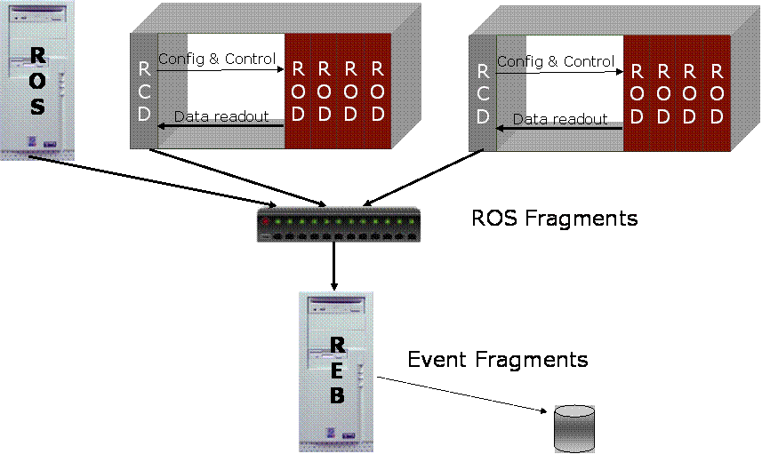

Figure 13. RCD event building system with one ROS and two crates as input.

In order to configure a system to include an REB, the following actions need to be performed in the database:
- set the ReadoutOutput of the ROSs and the RCDs in the crates to TCPDataOut. The TCPDataOut should have as DestinationNode the IP address of the REB machine and as DestinationPort the ROLPhysicalAddress of the corresponding InputChannel of the REB.
- set the ReadoutModule of the REB to EthSequentialReadoutModule. The REB should have as many input channels as ROSs and RCD crates are injecting ROS fragments into it.
- set the InputFragmentType in the EthSequentialReadoutModule to ROSFragments.
- set the Trigger in the REB to DataDrivenTriggerIn, and make it have as RequestType EBRequestWithRelease.
Figure 14 illustrates a configuration example in a simple one by one system.
MyReadoutModule
EthSequentialReadoutModule (ROSFragments)
TCPDataOut (DestinationPort = 10000)
EmulatedDataOut
EthSequentialInputChannel (ROLPhysicalAddress = 10000)
DataDrivenTriggerIn (EBRequestWithRelease)

REB
RCD crate
or ROS

Figure 14. Configuration of a one by one data driven event building system.

Note as well that the Configuration field of all the Readout Applications, RCD or ROSs, should be set to RCDConfig.
The DFConfiguration package includes a partition called PartitionROS_RCDEB.data.xml, which reflects a system with one ROS running one EmulatedSequentialDataChannel, and one RCD doing event building. The system runs fully in localhost, one should only have CMEM_BPA configured in both machines (used by EmulatedSequentialReadoutModule and EthSequentialReadoutModule).

Development, debugging

Code development, debugging and tracing

Run environment
For code development and debugging, it’s often convenient to run with a simple environment without the overheads and complexity of Online related software e.g. the IGUI. It’s possible to run the ROS/RCD software in interactive mode in which the user executes the run state transitions via a simple menu on the screen. In addition the user can specify whether configuration parameters should be retrieved from a database or from ASCII configuration files. ReadoutApplication –h explains the command line parameters.
- ReadoutApplication –i –n ApplicationName –c RCDConfig –k foo –v bar
This command will run the ReadoutApplication in interactive mode with the configuration plugin being RCDConfig which means that the parameters are retrieved from the standard ROS/RCD OKS database. The application name given by –n should match the UID of the ROS/RCD object in the database.
- ReadoutApplication –i –n ROS –c ROSAsciConfig –k foo –v bar
This command will run the ReadoutApplication in interactive mode with the configuration plugin being ROSAsciConfig which means that the parameters are retrieved from ASCII configuration files. The ASCII configuration files define directly name/value pairs that are read by code in the Module typically by methods like getInt(). Examples of configuration files are available in the ROSApplication package, directory: /config.

Debugging
In the RCD example code (as well as in the underlying code from the ROSModules package), debug macros from the package DFDebug are heavily used, in particular DEBUG_TEXT. The use of these debug facilities is strongly recommended, for a description, see Ref4
At a lower level a number of ROS/RCD specific Linux device drivers (vme_rcc, cmem_rcc, io_rcc, etc.) are used to implement specific functions and to control the access to the H/W. Some information about the state of these drivers can be obtained by looking at their special files in the /proc directory (e.g. “more /proc/vme_rcc). In addition the “root” user can send commands (e.g. “echo debug > /proc/vme_rcc”) to these drivers to enable or disable additional debugging information without having to reload the respective driver. The debug text of the drivers is written to /var/log/messages. This feature is more meant for experts.

Examples

RCD prototype system
To develop and test the RCD software, a RCD prototype system was built as shown in Figure 15. A ROD is emulated using a VMEbus memory module and an interrupt module. A utility program (VME_ROD_write) was developed to write ROD fragments with a user-defined size into the VMEbus memory so as to emulate a ROD data source. The trigger to read the ROD fragments was provided via a CORBO module which can be used in either polled or interrupt driven mode.
The user software consisted of the following (see also figure 1&2 in Ref1) which can be found in the package RCDExampleModules:
- VMEReadoutModuleUser as an example of <plugin>ReadoutModule
- ROD0DataChannel as an example of SpecificDataChannel
- ROD0InterruptHandler as an example of SpecificInterruptHandler
- ROD0ScheduledUserAction as an example of ScheduledUserAction

Figure 15 RCD prototype system

Module Methods
This section describes in some detail the methods in VMEReadoutModuleUser which is an example of a detector specific module. The module creates data channels that can be either polled or interrupt driven.

Setup
In a plugin, the setup method contains the code which normally would go in the constructor of the class. Parameters are extracted from the configuration but no ‘actions’ on the module are performed.
- A pointer to the global configuration is read from the ReadoutModule Config object and used to access the (global) database
- The VMEbus parameters, basically the VMEbus address and interrupt vector - for the module are retrieved.
- In a loop over the data channels, the channel parameters are computed and stored in vectors. They are derived from the module parameters in a detector specific way.

Load
In this example, the main function of the load method is to create the sequential data channels. The general rule is only that the channels should be created before the run is started.
- For each channel, the VMEbus parameters retrieved in setup are used to compute the virtual address that allows to access the VMEbus source of the data channel.
- The user data channels, ROD0DataChannel, are created. The parameters are the ‘standard’ ones described in 4.2 and in addition some VMEbus parameters including a definition of the interrupt source. The creation of one or more data channels will have the consequence that the IOManager will create a SequentialInputHandler thread, see Figure 6.
- A map of the data channels is built. This allows the interrupt handler to associate a vector with a data channel.
- A test is made to see if the data channels are associated with interrupts. In that case a user interrupt handler, ROD0InterruptHandler is created.
- A test is made to see if an error interrupt handler has been specifies by the user. In that case a user error interrupt handler, ROD0ErrorInterruptHandler, is created.
- A test is made to see, if a scheduled handler has been defined by the user. In that case a user scheduler action, ROD0ScheduledUserAction, is created. Also, a OH Raw Histogram Provider is created.

configure
In this example, the configuration method is empty.

prepareForRun
This method is called when the run is started.
- The L1id counters in the data channels are reset. This is implemented by calling a user method implemented in the ROD0DataChannel class.

startTrigger
This method is called as the last before the run is started.
- If interrupts are used, the interrupt controller of the CORBO is initialised
- Triggers are enabled
- A software flag blocking triggers is changed. This is implemented by calling a user method implemented in the ROD0DataChannel class.
- The method, startTrigger, on the ROD0ErrorInterruptHandler is called.

stopTrigger
This method is called as the first when a run is stopped.
- By symmetry it does the opposite of the startTrigger

stopFE
This method is called when the run is stopped.
In this example, the configure method is empty

Unconfigure
In this example, the unconfigure method is empty.

Unload
By symmetry, this method undoes what was done in load()
- For each channel, unmap the ROD data sources
- Close the VMEbus and CORBO libraries

Data Channel Methods
This section describes in some detail the methods in ROD0DataChannel which is an example of a detector specific data channel

constructor
- The constructor extracts user/detector specific parameters (VMEbus address and vectors) and stores it in local variables.
- And passes general parameters on to the SequentialDataChannel as described in 4.2
- The CORBO is reset and vectors written into it

getNextFragment
- A ROD fragment is read from the VMEbus memory module in VMEbus single cycle mode. The L1ID is computed.
- After having read the fragment, the channel is re-enabled. In case the readout is interrupt driven, this includes re-enabling the interrupts

poll
- A register in the CORBO is polled for the presence of a ‘data available’ bit. This function is only called when the data channel is operated in polling mode.

resetL1id, startTrigger, stopTrigger
- These additional user methods are called from the module when state transitions occur

Interrupt Handler methods
This section describes in some detail the methods in ROD0InterruptHandler which is an example of a detector specific interrupt handler

constructor
- The constructor builds a map that allows to associate interrupt vectors with data channels, see also Ref1.
- And passes the VMEbus interrupt descriptors on to the general interrupt handler

reactTo
- The reactTo method maps the VMEbus interrupt vector onto the corresponding data channel and calls the signalFragmentAvailable() method on this channel.

Error Interrupt Handler methods
This section describes in some detail the methods in ROD0ErrorInterruptHandler which is an example of a detector specific error interrupt handler

constructor
- The VMEbus interrupt descriptor is passed on to the general interrupt handler
- The CORBO channel is reset and a vector is written into it

reactTo
- The reactTo method prints an error message
- And re-enables the CORBO interrupt

Scheduled User Action methods
This section describes in some detail the methods in ROD0ScheduledUserAction which is an example of a detector specific scheduled user action.

constructor
- allocates space for a histogram

reactTo
- gets the value of the last timeslice
- puts this value into a histogram

printTimeHistogram
- prints the histogram to stdout

publishFullStatistics
- if the creation of the OH Raw Provider was successful, the histogram is published to IS. If not, the histogram is printed to stdout (if the ReadoutApplication is run in local mode, for example).

Performance

Appendix A: system issues
The ReadOut team supports two types of VMEbus SBCs in ROD crates: The VP110 and VP315/317 from Concurrent Technologies. For more information see:
http://atlas.web.cern.ch/Atlas/private/DIG/RCC/ (login required).
It is up to the user to decide how he wants to boot the Linux operating system. Both disk based and network booted systems are possible. Users are encouraged to use the available servers (contact Gokhan Unel or Markus Joos) were possible. In cases where this is not possible certain rules have to be followed. The RCD S/W has been developed and tested on systems with the CERN SLC3 release. There is no guarantee that the S/W will work with other distributions. System administrators can download a tested Linux kernel (based on SLC3) for network boot based configurations from /afs/cern.ch/to/be/defined.

The RCD S/W is based on a number of Linux device drivers for different purposes. These are:
Driver name | TDAQ package | Description | Documentation
vme_rcc | vme_rcc | VMEbus driver with support for single cycles, block transfers, interrupts, etc. | https://edms.cern.ch/document/325729/4
cmem_rcc | cmem_rcc | Allocation of contiguous memory for various purposes (e.g. DMA buffers) | https://edms.cern.ch/document/336290/2
io_rcc | io_rcc | Allows user code to access PCI and I/O registers | https://edms.cern.ch/document/349680/2
filar | ROSfilar | Support for FILAR S-Link interfaces with the standard SC firmware | https://edms.cern.ch/document/356135/1
filar_dma | ROSfilar | Support for FILAR S-Link interfaces with the high speed DMA F/W | https://edms.cern.ch/document/356135/1
solar | ROSsolar | Support for the S-Link data source on the S32PCI64 H/W | https://edms.cern.ch/document/386143/2
quest | ROSsolar | Support for the four channel S-Link data source on the FILAR H/W | Contact Markus Joos

As all of these drivers use module versions the driver binaries can only be installed on Linux kernels with exactly matching versions of the kernel symbols. Users of the standard kernel (see above) can download the drivers from /afs/cern.ch/to/be/defined.

Driver binaries for other kernels are not supplied by the Readout team. Users requiring them have to compile them directly from the source code. For that it is necessary to equip a development system with:
- A full TDAQ release. As the drivers require services from a (small) number of other TDAQ packages it is not sufficient to download just the package with the source code of the respective driver.
- Access to CMT. The compilation of the drivers (and related libraries and applications) is based on CMT requirements files.
- The kernel sources for the kernel for which the drivers are to be built.
- More information on how to download and install a TDAQ release can be found at: http://lnxatd01.cern.ch/cmt/releases/download/tdaq-01-01-00/

We have been using gcc version 3.2.3 for the development and testing of the S/W. Other compilers are not guaranteed to work. It is not possible to compile the drivers with the Intel icc compiler.

Appendix B: installing the RCD software

Kernel command line
The cmem_rcc driver can allocate contiguous memory in two ways. One of them requires that the kernel puts some memory aside at boot time. It is therefore necessary to tell the kernel how much memory has to be reserved. The way to do that is to add a statement like
bigphysarea=16384
to the kernel command line. This instruction tells the kernel to set a 64 MB buffer (16384 * 4k) aside for the BigPhysArea (BPA) kernel extension. The BPA is part of the SCL3 kernel but may be missing in other distributions.

Drivers
All TDAQ drivers are using dynamic major numbers. Therefore the device nodes have to be (re)created when a driver gets (re)loaded. For this purpose each package that contains a driver does also contain a script for loading the driver and creating the device node. These scripts have the same name as the driver and can be found in the “share/bin” subdirectory of a release or in the “driver” subdirectory of the source package. It is recommended to put these scripts (after some adaptations to the local directory structure) into the /etc/init.d directory and to enable them for the run level used by the SBC or PC.
All TDAQ drivers provide an entry in the /proc file system. Reading this special file (e.g. more /proc/vme_rcc) retrieves dynamically information about the current status of the respective driver. It is also possible to write to the /proc file to execute certain operation on a driver without reloading it. Common actions are enabling or disabling debugging information. A list of supported actions can be found by reading the /proc-file.

Specific configuration steps for the vme_rcc driver

Configuration file
Before any VMEbus cycles can be generated the Universe PCI to VMEbus interface on the VMEbus SBC has to be initialized. This is not done via the vme_rcc library but via a special application (vmeconfig) that should be run at boot time directly after the commands to install the driver (see code in the “vme_rcc” or “drivers”rcc” scripts). The “vmeconfig” application needs a configuration file that has to be generated by the user according to the individual set-up of his VMEbus crate. Information on how to generate this file can be found in:
https://edms.cern.ch/document/325729/4
http://cdsweb.cern.ch/search.py?recid=710506

Error logging
The vme_rcc driver has error logging switched on by default. If a VMEbus cycle fails (e.g. due to a bus error) or if the system receives spurious interrupts a message gets written to /var/log/messages. In most cases this feature does not harm but may be helpful for debugging certain types of errors and should therefore be left enabled. It can however cause programs (like scanvme) that generate lots of errors to run very slowly and /var/log/messages will fill up rapidly. Error logging can be disabled in two ways:
- Load the driver like that
/sbin/insmod -f /home/ATLAS/vme_rcc-`uname -r`.o errorlog=0
- Run as root
echo noelog > /proc/vme_rcc

Appendix C: Creating a configuration plugin
This section explains the necessary steps to create a configuration plugin. The new plugin should be derived from RCDConfig, as shows the following class diagram:
ROSDBConfig
getModule ()
getTrigger ()
getOutputChannel ()
RCDConfig
RODUserExampleConfig
UserConfig1
UserConfig2
…..
getModule()
getModule()
getModule()
Figure 16. Class diagram for the user configuration plugin
The configuration plugins created by the user only need to include the definition of the getModule() method. This method receives as arguments a pointer to the Readout Module and the Config object where to store the Readout Module parameters.
Two files need to be created:
    - a UserConfig.h file.
    - a UserConfig.cpp file,
The UserConfig.h file should include the definition of the configuration class, with a constructor, a destructor, and the getModule() method. In the getModule() method of the UserConfig.cpp file, the user can parse the different attributes and relationships of the Readout Module, and set appropiate pairs of keys/values in the Config object.
Later on, when editing the database, the RCD object has to include, in the Configuration field, the name of the configuration where the new module is defined (for example, “RODUserExampleConfig”). See an example in Figure 17.

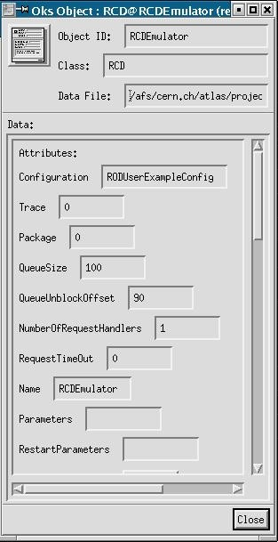
Figure 17. Where to include the configuration plugin in the database.
An example can be found at the RCDExampleConfiguration package.

This document has been prepared using the Short Note Template provided and approved by the ATLAS TDAQ and DCS Connect Forum. For more information, go to
http://atlas-connect-forum.web.cern.ch/Atlas-connect-forum/.
This template is based on the SDLT Single File Template that has been prepared by the IPT Group (Information, Process and Technology), IT Division, CERN (The European Laboratory for Particle Physics) and then converted to MS Word. For more information, go to http://framemaker.cern.ch/.

